|  |
| --- |
| SSRS –NOTES |
| www.enosislearning.com |
|  |

Table of Contents

Overview of SSRS 4

History of SSRS 4

New Features In SQL Server 2012 Reporting Services include:- 4

Architecture of SSRS 5

Components of SSRS 6

1. Report Authoring 6

SSRS Data Sources and Datasets 7

Explanation of Reporting Service Architecture 7

Extensions in SSRS 8

Business Intelligence Development Studio (BIDS) 9

SSRS Databases 10

What is a Report? 11

Report Definition Overview Diagrams: 11

Report Layout Diagram: 11

Report Data Diagram 12

Report Items 12

Tablix 13

Creating a SSRS Report Using Wizard 13

Step 1 : 14

Step 2: Creating Data Source 15

Step 3: Write Query 16

Step 4: Select Report Type 16

Step 5: Select Report Fields 17

Step 6: Select Table Layout 17

Step 7: Select Color Scheme 18

Step 8: Select Report Name 18

Step 9 : View Report 19

Creating a SSRS Report without Using Wizard 20

Step 1: Open BIDS 20

Step 2: Add a Empty Report 20

Step 3: Add a Data Source 21

Add a Data Source and Dataset to the Project 21

Add Data Elements to the Report 22

Format the Report and Export 22

Chart Types 23

Report Parameters in SSRS 2012 25

Creating Report Parameters 26

STEP 3: Creating Parameters 27

STEP 4: Assigning Values to Parameters 27

STEP 5: Linking Parameters to Report DataSet 28

PARAMETER WITH LIKE OPERATORS 29

BAR CHARTS WITH CHARTS 30

SSRS Expressions 33

Reporting Services Expressions 33

Examples of SSRS Expression 33

Date & Time Functions 34

String Functions 35

Expressions and Custom code 37

Example : 37

Writing Custom Expression Code 37

Calling Custom Expression from Reports 38

Conditional Formatting Using Expression in SSRS 42

Calculated Fields 44

Lab Example [Writing Custom Code for Expressions] 46

Drilldown Report in SSIS 47

DRILL DOWN IN CHARTS 50

SUBREPORTS 55

Sorting of Columns 58

Paging in SSRS report 59

DEPLOYMENT 61

Sql Server 2012 Reporting Service Configuration Manager 61

Deploy SSRS Report Server Project 65

UPLOADING REPORTS USING REPORT MANAGER 70

User Roles and Permissions in SSRS 71

SSRS Integration with ASP.Net 76

Invoking the deployed report from Asp.net. 76

CALLING SSRS REPORTS WITH PARAMETERS 78

# Overview of SSRS

* SSRS is Reporting Tool From MS for really ease of Developing any type of report
* It provides a unified, server-based, extensible, and scalable platform from which to deliver and present information.
* Its scope extends from traditional paper reports to web-based delivery and interactive content.
* SSRS can also be configured to deliver reports to peoples’ inboxes, file shares, and so on. SSRS is capable of generating reports in various formats, such as the web-oriented Hypertext Markup Language (HTML) and desktop application (Microsoft Excel and CSV) formats, thus allowing users to manipulate their data in whatever format is required.
* SharePoint can be used as a front end for SSRS, allowing reports to be presented directly in corporate portals.

**SSRS Example**

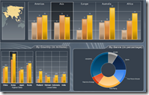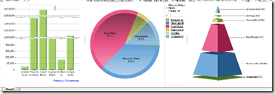

## History of SSRS

* Originally Released in 2004 as a web release for SQL Server   
  2000   
  • Included as part of the product in SQL Server 2005 with   
  many enhancements   
                  – Report Models and Report Builder   
                  – Multi-Valued Parameters   
                  – Printing Support   
  • Enhanced again for inclusion in the SQL Server 2008 release   
                  – New “Tablix” implementation of report elements   
                  – Inclusion of Dundas charting and gauge compon

## New Features In SQL Server 2012 Reporting Services include:-

* + Power View
  + Improved SharePoint Integration Mode
  + Word Rendering for Microsoft Word 2007-2010 and Microsoft Word 2003
  + Excel Rendering for Microsoft Excel 2007-2010 and Microsoft Excel 2003
  + Self-Service Alerting or Data Alerts

# Architecture of SSRS

The core of Reporting Services functionality is implemented as a Windows service.  While an in-depth understanding of this implementation is not required to use Reporting Services, it is nonetheless interesting at least in terms of a high-level description.

The Reporting Services Windows service provides the following functionality as shown below in this diagram taken from Books on Line:

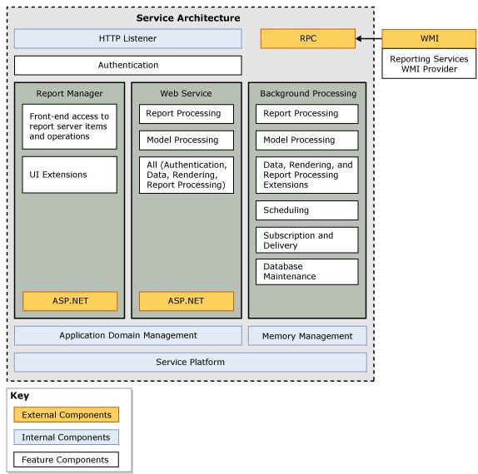

The following are the main points about the SSRS service:

* The HTTP listener is a new feature; prior versions of Reporting Services required Internet Information Server (IIS).
* Report Manager is an ASP.NET application that provides a browser-based interface for managing Reporting Services.  We will cover the Report Manager in a later section.
* The Web Service is also implemented as an ASP.NET application; it provides a programmatic interface to Reporting Services.  The Report Manager uses the web service.  You can use the web service to create your own custom implementation of any feature provided by the Report Manager.
* Background Processing provides the core services for Reporting Services.
* The Report Manager, Web Service, and Background Processing are each implemented as separate application domains.

**Architecture of SQL Server Reporting Services**The following diagram shows the architecture of SQL Server Reporting Services.  
  
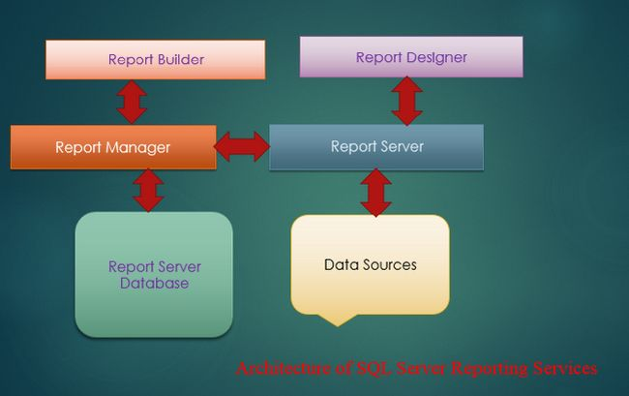  
 **Tools and Components of SQL Server Reporting Services architecture**  
  
This architecture consists mainly of the following types of components and tools.

* Report Builder
* Report Designer
* Report Manager
* Report Server
* Report server database
* Data sources

**Report Builder**

* This component can be used to drag and drop and for easy to use report design functionality. Report Builder is an ad-hoc end-user report publishing tool that is executed on a client computer.

**Report Designer**

* The Report designer tool can be used to develop simple and complex reports. Report Designer is a publishing tool,  that is hosted in Business Intelligence Development Studio (BIDS) or Visual Studio.

**Report Manager**

* This tool provides easy access to web-based reports. The default URL of the Report Manager is http://<server>/reports.

**Report Server**

* It is a server that uses the SQL Server database engine to store metadata.

**Report server database**

* It stores metadata, resources, report definitions, security settings, delivery data and so on.

**Data sources**

* Reporting services retrieves data from data sources like relational and multidimensional data sources.

**Processing of SQL Server Reporting Services**This diagram shows the processing of SQL Server Reporting Services.  
  
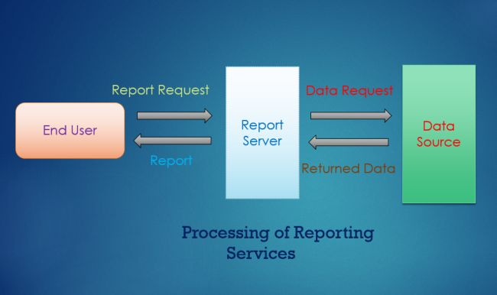  
  
On a report server, or a different server we choose, we will have access to the Report Manager website. The Report Manager website can be used to deploy and manage reports. End users run reports by the Report Manager and publish their reports if they have permission. An SQL Server Reporting Services is associated with a SQL Server instance. The SQL Server instance has two databases, the first is a report server and the second one is ReportServerTempdb. The end-user sends a HTTP request for a report. The report server finds the metadata of the report and sends a request for data to the data source then after the data is returned by the data source and merged with the report definition into a report. When the report is generated then it is sent to the client.

# Components of SSRS

## Report Authoring

The Report Authoring tools **produce,** as their end-product, **RDL files** that specify the way that the report will work.

The report designers of SSRS are of two types: ‘Report Builder’ designed for end users and ‘Report Designer’ designed for developers

## Report Builder

Report Builder is an ‘ad-hoc reporting tool’, and designed for IT-savvy users (normal users) to allow them to specify, modify and share the reports they need. It **allows the creation of reports derived from ‘report models’** that provide a business-oriented model of the data. The Report Builder allows the users to specify the way data is filtered and sorted, and allows them to change the formulas of calculated columns or to insert new columns.

## Reports in Application:

There are alternatives. Such as using the Web Browser control or the Report Viewer control.

To use the **web browser control** in an application, all one needs to do is to provide the URL of the report server. The URL parameters provide precise control over what information is returned. Using the appropriate parameters, not only can you get the report itself for display, you can also access the contents of the Data Source as XML, the Folder-navigation page, the child items of the report, or resource contents for a report

The **report viewer control**, ‘Report Viewer’, ships with Visual studio and can be used in any Windows Form or web form surface, just by dragging and dropping. After you assign a report url and path, the report will appear on the control. You can configure the Report Viewer in a local report-processing mode where the application is responsible for supplying the report data.

One can use the **Report Server Web Service** to gain access to the report management functionality such as content, subscription and data source, on top of all the facilities provided by using a URL request. This allows reporting via any development tool that implements the SOAP methods. This Web Service approach provides a great deal of control over the reporting process greatly facilitates the integration of Reporting Services into applications, even where the application is hosted in a different operating environment

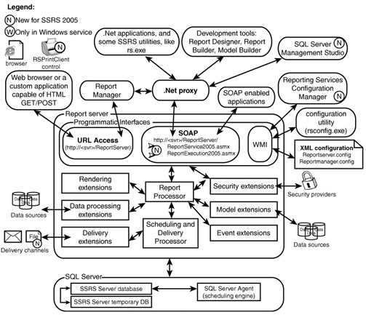

Reporting Services Components Summary

| Component | Brief Description |
| --- | --- |
| Programmatic interfaces | Provides access to SSRS functionality through SOAP and HTTP requests. |
| Report Processor | Facilitates a set of report generation operations from data retrieval to rendering. Report Processor invokes other components, such as data extensions to assist with report generation. |
| Data-processing extensions | Retrieves report's data from a data source. Developers can develop additional custom data-processing extensions. |
| Command-line utilities | Three utilities, designed to assist with scripting of administrative tasks, installed automatically during the Reporting Services install. |
| Rendering extensions | Transform the report's intermediate format (a combination of report's layout and data) into a device-specific format, such as HTML. Developers can create new rendering extensions. |
| Report Server database | Stores report definitions, report metadata, report history, cached reports, snapshots, resources, security settings, encrypted data, scheduling and delivery data, and more. |
| Report Server temporary database | Stores intermediate processing products, cache, and data. |
| Scheduling and Delivery Processor | Monitors for events (such as timed subscription), collaborates with Report Processor to render a report, and delivery extensions to deliver scheduled reports to a location specified in the subscription. |
| Delivery extensions | Deliver reports to specific devices, such as email or a file system. Developers can create new delivery extensions. |
| Report Manager | Provides web-based report access and management capabilities. Default URL that invokes Report Manager is http://<server>/reports. |
| Report Model Designer | Generates report models for use in Report Builder. |
| Report Builder | Provides drag-and-drop, easy-to-use report design functionality. Report Builder is an ad hoc end-user report authoring and publishing tool executed on a client computer. |
| Report Designer | Allows developers to develop complex reports. Report Designer is a comprehensive report authoring and publishing tool, hosted in Business Intelligence Development Studio or Visual Studio. |
| Security extensions | Enable authentication and authorization of users and groups. Developers can (excluding SQL Server Express edition) create new security extensions. |
| SQL Server Management Studio | Provides administrators with Windows form-based, integrated environment to manage SQL Server components including SSRS. From the report management perspective, Management Studio has similar functionality to Report Manager, but provides additional capabilities, such as consolidated web-farm management. |
| Reporting Services Configuration Tool | Provide administrators with functionality to start and stop Report Server Windows service and reconfigure report servers. This is a Windows forms application. |
| WMI provider | Provides a set of WMI interfaces to manage settings of a Report Server and assists with SSRS instance discovery on a network. |
| Performance monitoring objects | Provide a view of SSRS Windows and web service performance. |

### The Reporting Services Architecture(briefly)

For a relatively new product, Reporting Services has a quite complex architecture. The full Reporting Services architecture includes development tools, administration tools, and report viewers. There are a number of ways to get to Reporting Services programmatically, including SOAP and WMI interfaces.

# SSRS Data Sources and Datasets

**SSRS Data Sources**

The information contained within a data source definition varies depending on the type of underlying data, but typically includes information such as a server name, a database name, and user credentials.

**SSRS Data Sets**

A Reporting Services dataset is the metadata that represents the underlying data on a specific data source. It contains a data source definition, a query or stored procedure of the data source and a resulting fields list, and the parameters if any, calculated fields, as well as the collation

**Dataset Fields**

Each dataset in a report contains a collection of fields. These fields generally refer to database fields and contain a pointer to the database field and a name property but this can be overwritten with a more meaningful name where necessary. These fields can, alternatively, be calculated fields, which contain a name and an expression

# Reporting Service Architecture OverView

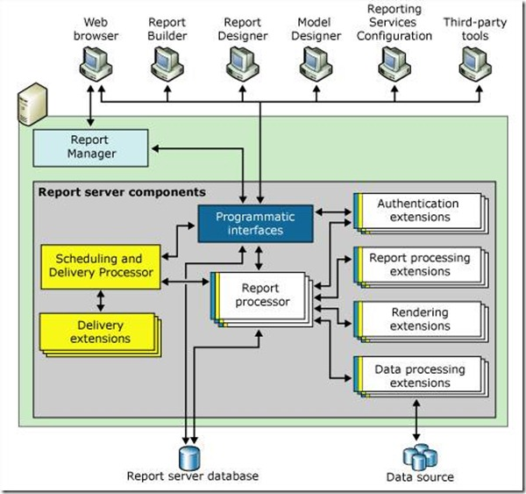

The report server includes three applications that run in the same Windows service:

· **Report Manager**, which is represented by the Report Manager component in the diagram. Report Manager is a browser application that provides front-end access to the Reporting Services Web service.

· **Reporting Services** Web service, this is represented by the Web service components in the diagram. This application handles on-demand, interactive report processing.

· **Background processing application**, which is represented by the Windows service components in the diagram. This application processes reports that are triggered from a schedule and delivers reports to target destinations.

**Data Storage:**

The report server is a stateless server that stores all properties, objects, and metadata in a SQL Server database. Stored data includes published reports, report models, and the folder hierarchy that provides the addressing for all items managed by the report server. A report server database can provide internal storage for a single Reporting Services installation or for multiple report servers that are part of a scale-out deployment.

# Extensions in SSRS

The report server supports custom authentication extensions, data processing extensions, report processing extensions, rendering extensions, and delivery extensions. A report server requires at least one authentication extension, data processing extension, and rendering extension. Delivery and custom report processing extensions are optional, but necessary if you want to support report distribution or custom controls.

**Security Extensions**

Security extensions are used to authenticate and authorize users and groups to a report server. The default security extension is based on Windows Authentication.

**Data Processing Extensions:**

Data Processing extensions are used to query a data source and return a flattened row set. Reporting Services uses different extensions to interact with different types of data sources. You can use the extensions that are included in Reporting Services, or you can develop your own extensions. Data processing extensions for SQL Server, Analysis Services, Oracle, SAP NetWeaver Business Intelligence, Hyperion Essbase, Teradata, OLE DB, and ODBC data sources are provided. Reporting Services can also use any ADO.NET data provider. Data processing extensions process query requests from the Report Processor component by performing the following tasks:

· Open a connection to a data source.

· Analyze a query and return a list of field names.

· Run a query against the data source and return a rowset.

· Pass parameters to a query, if required.

· Iterate through the rowset and retrieve data.

**Rendering Extensions:**

Rendering extensions transform data and layout information from the Report Processor into a device-specific format. Reporting Services includes seven rendering extensions: HTML, Excel, CSV, XML, Image, PDF, and Microsoft Word.

**Report Processing Extensions:**

Report processing extensions can be added to provide custom report processing for report items that are not included with Reporting Services. By default, a report server can process tables, charts, matrices, lists, text boxes, images, and other report items.

**Delivery Extensions**

The background processing application uses delivery extensions to deliver reports to various locations. Reporting Services includes an e-mail delivery extension and a file share delivery extension. The e-mail delivery extension sends an e-mail message through Simple Mail Transport Protocol (SMTP) that includes either the report itself or a URL link to the report.

# Business Intelligence Development Studio (BIDS)

When you first open Business Intelligence Development Studio, the Start Page appears in the center of the Business Intelligence Development Studio user interface. After you open an object in a project, the designer for working with that object also appears in the center window.

**Tool Window in BIDS:**

**[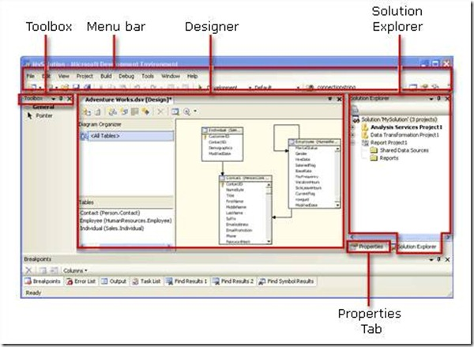](http://bimentalist.files.wordpress.com/2011/11/clip_image004.jpg)**

Business Intelligence Development Studio consists of four main windows:

· Solution Explorer

· Properties Window

· Designer Window

· Toolbox

**Solution Explorer**

In Solution Explorer, you can create empty solutions and then add new or existing projects to the solution. If you create a new project without first creating a solution, Business Intelligence Development Studio automatically creates the solution too.

**Properties Window**

The Properties window lists the properties of an object. You use this window to view and change the properties of objects, such as packages, that are open in editors and designers

**Toolbox Window**

The Toolbox window always displays the General tab, and may also display tabs such as Control Flow Items, Maintenance Tasks, Data Flow Sources, or Report Items.

Some designers and editors do not use items from the Toolbox. In that case the Toolbox contains only the General tab.

**Designer Window**

The Designer window is the tool window in which you create or modify business intelligence objects. The designer provides both a code view and a design view of an object. When you open an object in a project, the object opens within a specialized designer in this window. For example, if you open a data source view in any of the business intelligence projects, the designer window opens using the Data Source View designer.

**Working with Solutions and Projects:**

When you create a new solution, Business Intelligence Development Studio adds a Solution folder to Solution Explorer and creates files that have the extensions .sln and .suo.

· The *.sln file contains information about solution configuration and lists the projects in the solution.

· The *.suo file contains information about your preferences for working with the solution.

SSRS Stands for SQL Server Reporting Services

# SSRS Databases

• ReportServer  
 Stores all the reporting services assets   
 Reports   
 Datasources  
 Security   
 Snapshots & Histories   
 Schedules & Subscriptions   
• ReportServerTempDB  
 Stores temporary “Intermediate Reports”   
• Sizes of the DBs depends on   
 Number of Reports   
Execution Properties

# What is a Report?

A report is a combination of three kinds of information:

* **Data** or information about how to obtain the data (queries) as well as the structure of the data.
* **Layout** or formatting information that describes how the data is presented
* **Properties** of the report, such as author, parameters, images within the report, and so on

# Report Definition Overview Diagrams:

Following section contains diagrams that illustrate the schema of the Report Definition Language

## Report Layout Diagram:

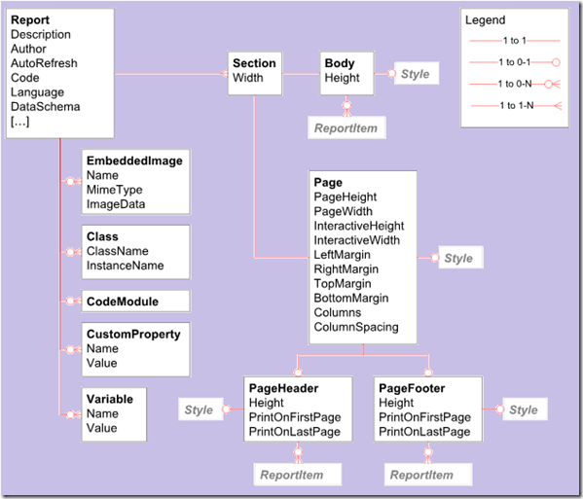

## Report Data Diagram

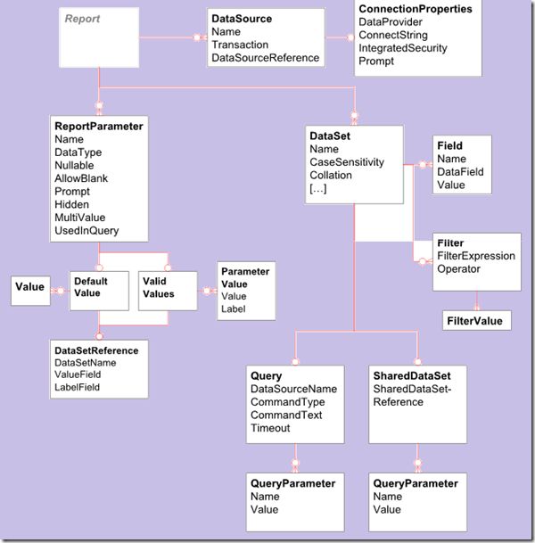

## Report Items

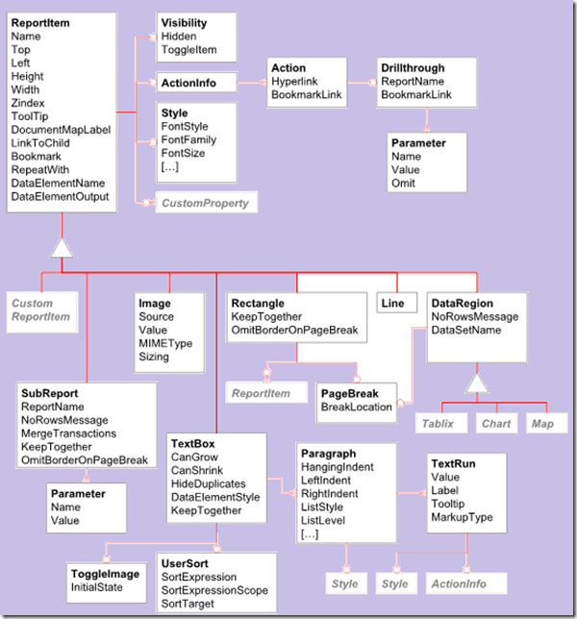

## Tablix

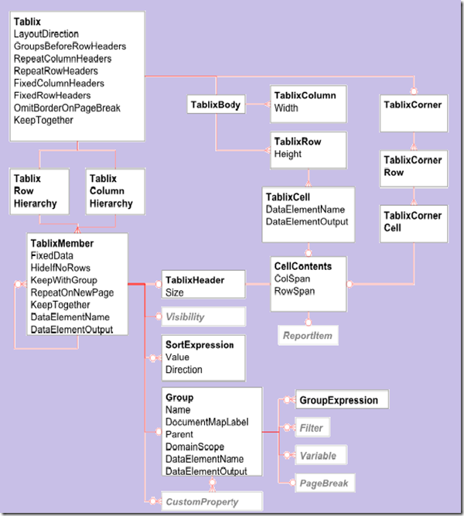

**Chart**

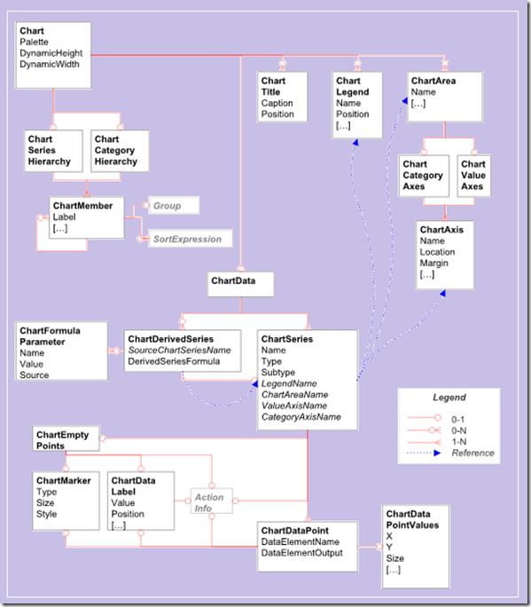

# Creating a SSRS Report Using Wizard

Once a new project is selected, a list of templates will be available as shown in the screen below.

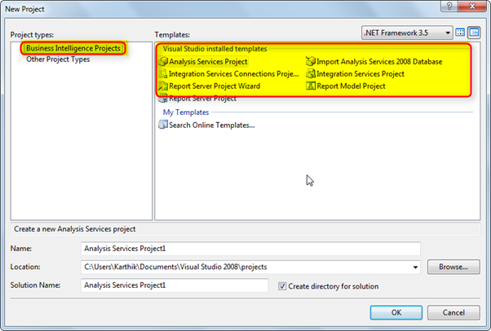

As we are in Business Intelligence Studio, the list of template will not have the normal templates (C#, VB.Net, Office etc).

Now the next step is to create a report using the Report Wizard.

Step 1 : To do this, select the Report Server Project Wizard as shown in the screen below.

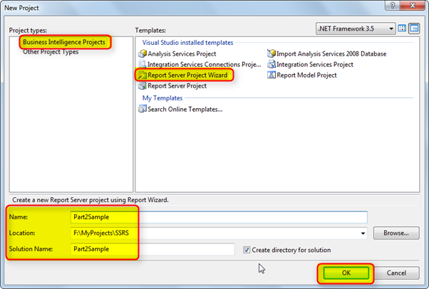

Once we select the **Report Wizard** and provide a valid name to the project as shown in the screen above, click on **OK** to create the project. Once the project is created, we can see a screen as shown below.

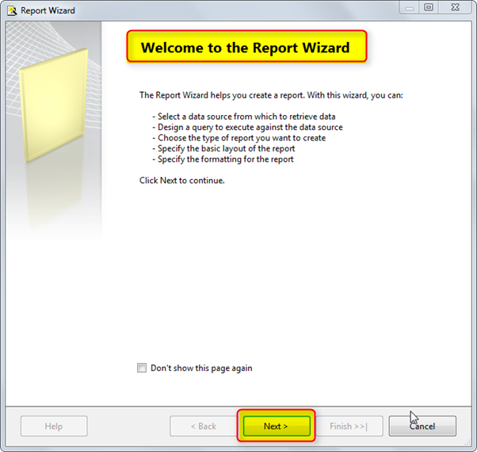

This is the start-up screen. To stave off the start up screen in the future, we can select the option “Don’t show this page again”. Once we are done with the above changes, click on the **Next** button to proceed further.

## Step 2: Creating Data Source

Now we can see a new window requesting for the data source input details. In this input request, we can either configure a shared data source or create a new data source as per the requirement. In our example, we will create a new data source as shown in the screen below.

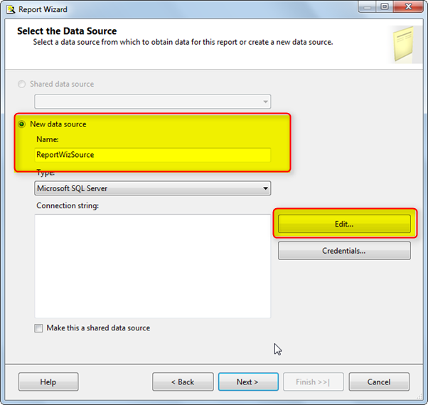

Next, click on the **Edit** button and edit the connection string to connect to the database from which the data has to be retrieved to present in the reports. On clicking **Edit** button a window will open as shown in the screen below.

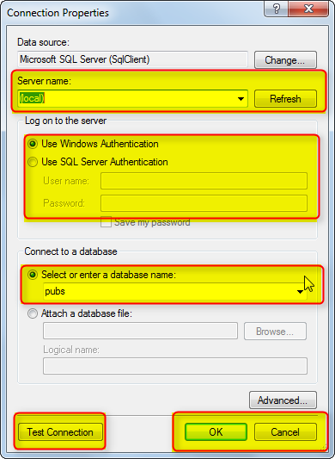

Once we have provided the above details (It may change as per your system database), click on **Test Connection** to test if the connection is successful. Once the connection is successful, click on **OK** and we can see the window as shown in the screen below.

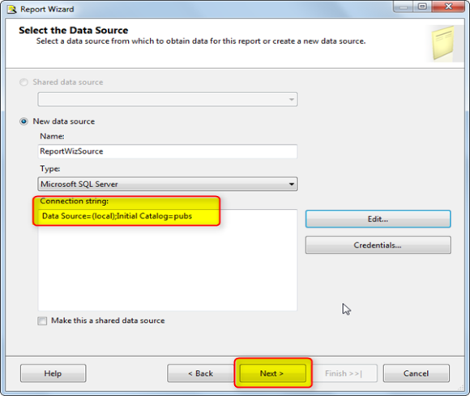

Clicking on **Next** button will move to the next step in the wizard, which is the Query Builder.

## Step 3: Write Query

Write the query as shown in the screen below. Now click on **Next** to proceed further.

***Note: You also have option to build query using query Builder. Click on Query Builder***

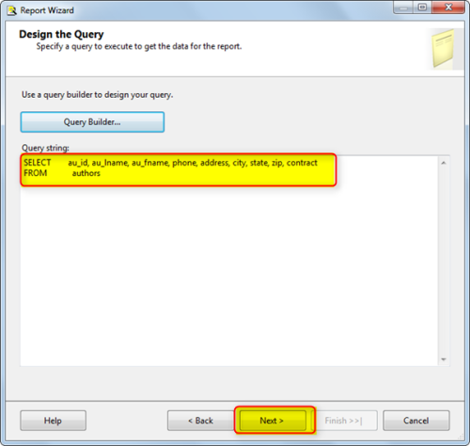

## Step 4: Select Report Type

Now we can see an option to select the format in which the data can be displayed. The Wizard has two options (Tabular and Matrix) that can be used based on the requirement.

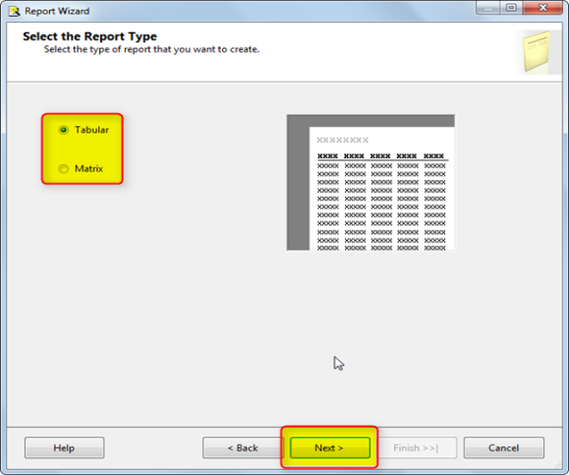

## Step 5: Select Report Fields

Once we select the required format and click on the **Next** button, we will get a window to select fields that has to be displayed. Here we have more control over the data display, such as; we can select the data that should be displayed at the header or to group the data in a particular format as shown in the screen below.

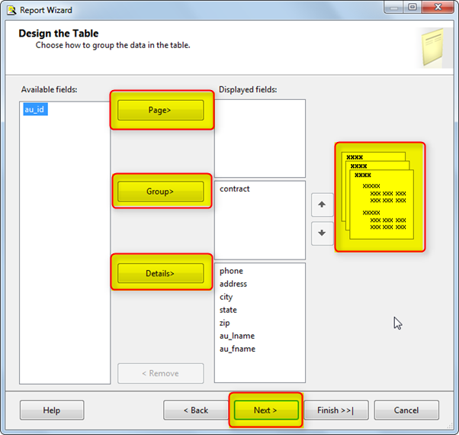

## Step 6: Select Table Layout

Once selected, click on the **Next** button to move to the next screen. The next screen allows selecting the layout of the report as shown in the screen below.

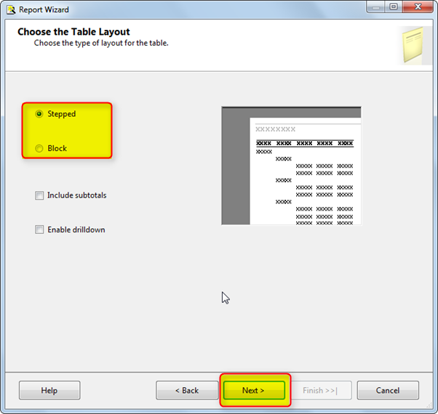

Selecting **Stepped** option and clicking on the **Next** button will open a new window to select the style.

## Step 7: Select Color Scheme

This will allow us to display the report with a good look and feel. The report wizard displays a list of styles available as shown in the screen below. Select the required style and click on **Finish** button to complete the wizard.

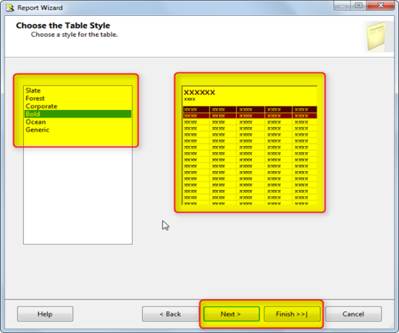

## Step 8: Select Report Name

A summary of the options selected will be presented with the data source as shown in the screen below. Click on **Finish** button to complete the process.

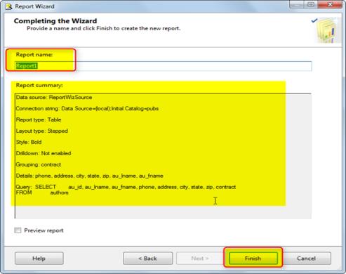

Clicking on **Finish** button will open the report in the designer view of the Business Intelligence Development Studio as shown in the screen below.

## Step 9 : View Report

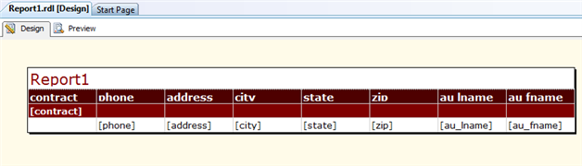

Now Press F5 or hit the **Play** button from the tool bar to start building and executing the report. Once the process is started and we can see the report generation in progress as shown in the screen above.

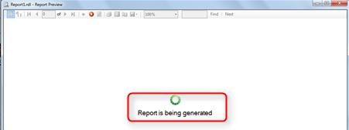

Once the report generation is completed, we can see report in a nice format as shown in the screen below, which is also our expected output.

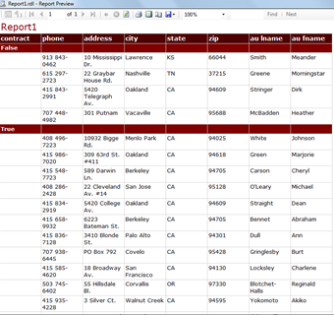

# Creating a SSRS Report without Using Wizard

To create a report manually in Business Intelligence Development Studio (BIDS):

## Step 1: Open BIDS

Open BIDS.  Select File > Open > Project/Solution.

* + Locate and open the previously created Report Server Project.
  + In the Solution Explorer, right-click the Reports folder and select Add > New Item.
  + Select "Report" from the Add New Item window, and name the report (e.g., "MyReport.rdl"). Click OK.

## Step 2: Add a Empty Report

Add a New Report By clicking

You now have an empty SSRS report open in BIDS.

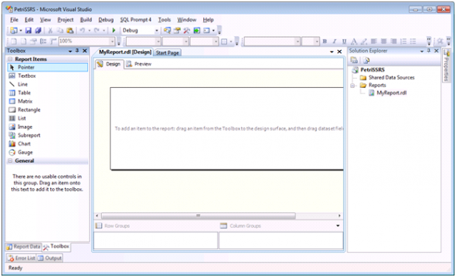

On one side of the screen, you should see tabs for Toolbox and Report Data. If either of these tabs is not visible, select the appropriate tab from the View menu.  The **Toolbox** tab displays the items available to your report, such as textboxes and tables.  The **Report Data** tab displays the available data elements, which can include result sets from your data sources, images, and built-in report fields (like "Page Number").

## Step 3: Add a Data Source

## Add a Data Source and Dataset to the Project

A **data source** identifies the database (or other data object, such as an XML file) from which you wish to pull data, and the connection properties used to connect to it - such as server name and login credentials. To add a data source to your report:

1. On the Report Data tab, select New > Data Source. Give the data source a meaningful name.
2. Select the "Use shared data source reference" radio button.
3. Select the previously created SQL Server data source from the drop-down menu. Click OK.

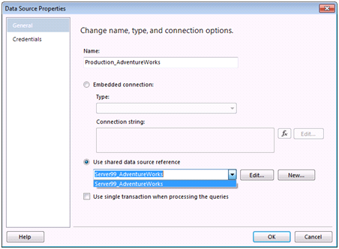

A **dataset** is the specific set of data requested - via a query or stored procedure execution - from the data source.  The dataset defines what data is available to display in the report.  To add a dataset to your report:

1. On the Report Data tab, select New > Dataset. Give the dataset a meaningful name.
2. Select the data source you added in the steps above.
3. This screen allows you to type or paste your query or stored procedure call; or you can click "Query Designer" to build your query in the graphical design.  Paste the following query in the Query text area:

SELECT P.Name ,ProductNumber, Color ,ListPrice ,SC.Name [Category]FROM Production.Product PLEFT OUTER JOIN Production.ProductSubCategory SC  
ON P.ProductSubCategoryID = SC.ProductSubCategoryID  
WHERE ListPrice BETWEEN 0 AND 1000  
ORDER BY Category, ListPrice ASC

1. Click OK.

You can now see the data set and available data fields in the Report Data tab.

## Add Data Elements to the Report

Now that you have defined your dataset, you can begin to build the report itself, starting with a table of products, title, and page number:

1. Drag a **Table** item from the Toolbox tab onto the surface of your report.
2. From the Report Data tab, drag and drop the data fields **Category, Color, Product, Name**, and **List Price** into columns in the empty table.



1. Drag a **Textbox** item from the Toolbox tab onto the surface of your report, above the table. Type "AdventureWorks Products" in the textbox.
2. On a blank area of the report, right-click and select Insert > Page Footer.
3. Drag a textbox item into the footer. From the "Built-In Fields" section on the Report Data tab, drag "Page Number" into the textbox.
4. Click the Preview tab above the report area to see the report populated with data.

## Format the Report and Export

The Design tab allows many options to improve the report presentation, including:

* **Add and delete columns** - Right-click the table and select Insert Column > Left (or Right).
* **Change the column widths** - Drag and drop column header borders.
* **Change text font and style** - Select the fields and apply changes from the format toolbar.
* **Format numeric fields** - Right-click the numeric field, select "Text Box Properties", and make changes using the Number option (for example, List Price might be displayed as Currency).
* **Change the report area** - Drag the edges of the report to make it larger or smaller, or drag the border of the footer to move it closer to the end of the table.

The size of the report area may impact the way the report is displayed when you export it. For example, if you export to PDF at standard size (8.5 x 11") portrait layout and your report is too wide, the report will contain extra pages to accommodate the extra width.  Use the ruler (right-click and select View > Ruler) to monitor the report width, and modify the report page layout and borders as needed in Report > Report Properties.

# Chart Types

Some of the more common chart types (like Column, Bar, Line, and Area) can be used for different views of the same data. Pie and doughnut charts present a more simplified view and work well with fewer dimensions. Other charts are more specialized and may be appropriate for multi-value data points, range values, and variances.

When a report is viewed, the chart output is rendered to a bitmap and streamed to a PNG-type image. This image is then linked or embedded in the report. There are nine general chart types available, and these are described in the following table.

|  |  |
| --- | --- |
| **Chart Type** | **Description** |
| Column | This is a classic vertical bar chart with columns representing values along the Y-axis. Like-valued items along the X-axis are grouped together, and bars representing the same X-axis values in each group have the same colors or patterns. Series values may also be grouped and subgrouped.  3D Column Charts  3-D modeling may be used to show data in a more interesting presentation, but this can also be distracting and less effective for analysis. |
| Bar | This functionality is the same as a column chart turned 90 degrees. It has the advantage of more accurately depicting value comparisons for layouts where you have more available horizontal space. |
| Area | Like a column chart with a trend line drawn from one point to the next in the series. This type of chart is appropriate for a series of values that tend to progress over a relatively even plane that describes a "level," "up," or "down" trend. It is not at all appropriate for series values that tend to jump around. The solid shading of the charted area depicts a volume of data values.  Figure 6 |
| Line | Like the area chart, but the area of the charted area isn't filled. This type of chart is useful for comparing multiple series (along the Z-axis) without obscuring trend lines behind a series. |
| Pie | The classic pie chart is an excellent tool for comparing relative values. Unlike bar, column, line, and area charts, the aggregate value isn't quantified. Users understand pie charts because they put comparative values into a proportional context and can drive quick decision support at a glance. Pie chart views can be exploded to visually separate each slide.  Figure 7 |
|  |  |
| Doughnut | A doughnut is a pie with a hole in the middle. A three-dimensional doughnut rendering may expose smaller slices more clearly than a pie chart since each slice has four sides rather than three.  Figure 8 |
| Scatter | Plots several points in a range (both X and Y) to show trends and variations in value. The result is more like a cloudy band of points rather than a specific aggregated point or line. |
| Bubble | This chart is a technique for charting points on three dimensions. Values are plotted using different-sized points, or bubbles, on a two-dimensional grid. The size of the bubble indicates the related value along the Z-axis.  Bubble charts are essentially a point plotted in a grid representing three dimensions. The value of the Z-axis is expressed by the size of the bubble. Imagine that the bubble exists in a 3-D plane and will appear large if it is closer to you. Actually the "bubble" can be a circle, square, triangle, diamond, or cross shape. This also means that a combination of shapes may be used to represent different data elements in the same chart space.  Figure 11 |
|  |  |
| Stock | This chart plots values vertically like a column chart. For each item along the Y-axis series, a vertical line indicates a start and end value for the range. A tick mark in the line can indicate a significant value in that range or an aggregation of the range. This type of chart is useful for showing trading stocks with opening, closing, and purchase values; wholesale, retail, and discount prices; and the like. |

**The Anatomy of a Chart**

There is typically a lot of detail work involved in chart design and many properties to manage. Figure 13 shows the major property groups for charts. Although some charts have a few unique properties and some may not support all, generally these are shared across all chart types.

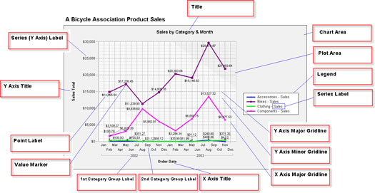  
*Figure 13*

After the chart is placed in the report body, fields may be dragged from the Dataset window directly onto the chart design surface. At minimum, a chart should have one aggregated field for the value and one grouped field for the category. The category and series groups represent the X- and Y-axis in bar, column, line, area, and point charts.

# Report Parameters in SSRS 2012

**Report Parameters in SSRS**  
In SSRS, parameters are used to specify the data to use in a report, narrow down your report data for better analysis, connect related reports together, and vary report presentation. Report parameters can be Single-Valued and Multivalued.  
  
**Using Parameters in Reporting Services:**  
The most common use of parameters is to vary report data retrieved by dataset queries. In this scenario, users are prompted for a value or values when they run the report, and the dataset query retrieves only the data that is requested. You can change the report parameter properties in the report design tools to include a valid values list that displays at run time.  
  
You can also create cascading parameters, which retrieve hierarchical data from a data source. I'll explain cascading parameters in my nect post. First I want to explain creating a report parameter in SSRS 2012.  
  
Below are the uses of report parameters:

* **To Control Report Data** - by selecting required parameters values to filter the report data.
* **To Control Report Appearance** - use parameters to change report appearance using expression-based properties, including conditionally hiding report items and conditionally changing text color.
* **To Connect to Other Reports** - use parameters to link to drillthrough reports, subreports, and linked reports.
* **To Select Specific Data Columns** - parameters can be used to select specific columns of a table/matrix at run time.

Creating Report Parameters  
Query parameters are added to a dataset query by way of the query designers or the Dataset Properties dialog box. After you create a query with parameters, Reporting Services automatically links query parameters to report parameters with the same name. Below are the steps to create parameters:  
  
STEP 1: Creating SSRS Project  
To begin, start a new Report Server Projectproject in BI 2012 by clicking on **Start** -->**All Programs** -->**SQL Server 2012** -->**SQL Server Business Intelligence Development Studio**. Then, from the menu, select **File** -->**New** -->**Project** to open New Project wizard. Now select **Report Server Project** from Visual studio installed templates and specify Name, Location and Solution Name.   
  
STEP 2: Creating Dataset for Parameters  
Create a new Data Set for the report parameter. I will add a dataset **dsDesignation** for Employee's Designation using query   
SELECTDISTINCTDesg AS Designation FROM Employee   
as shown below:

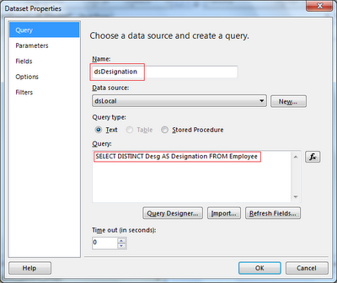

STEP 3: Creating ParametersNow I will add a parameter Designation. In **Report Data** section, right click on **Parameters** node and click **Add Parameter...** as shown below:

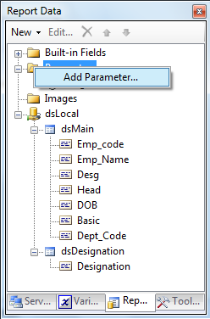

In **Report Parameter Properties** window, enter **Name** and **Prompt** of the parameter and select the **Data type** from dropdown box. For our example, enter **Designation** in Name and Prompt text boxes and select **Text** as data type.

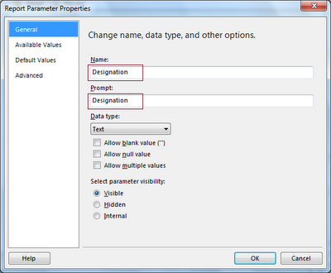

STEP 4: Assigning Values to Parameters  
Now click on **Avaliable Values** to set available values for the parameter. Select **Get values from a query**. Select **dsDesignation** as Dataset, **Designation** as Value field and Label field.

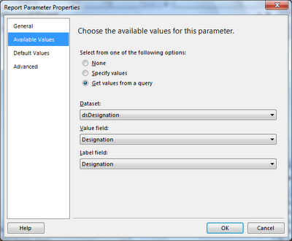

Click on **Default Values**, Select **Get values from a query.** Select **dsDesignation** as Dataset, **Designation** as Value field. Click OK to save changes.

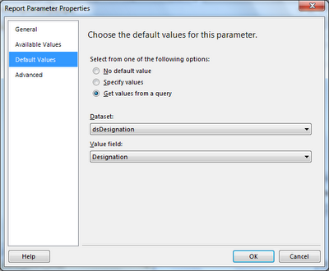

STEP 5: Linking Parameters to Report DataSet  
Double click on your main dataset (dsMain) to open **Dataset Properties**. Now Select  **Parameters** and click on **Add** button to map Designation parameter.   
  
Now final step, just add parameter in your query as shown in below snapshot:  
WHERE [Desg] = @Designation

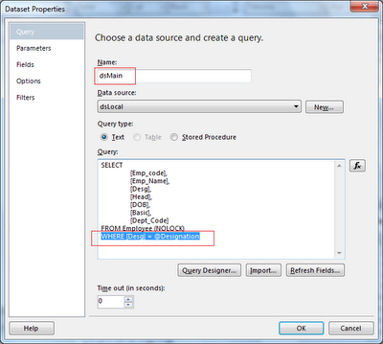

Now preview the report to check the action of parameter used:

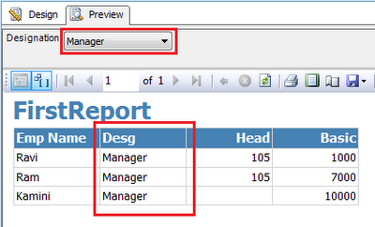

Based upon Selection of Parameters the report data will be filtered.

## PARAMETER WITH LIKE OPERATORS

You could also simply use string concatenation in the original Dataset that you want to filter on. You can access the parameters in the same manner as SQL:

WHERE fieldname LIKE '%' + @test + '%'

You can then link the report parameter @test to the @test in the dataset via the parameters option on Dataset Properties.

Eg : Select * from DimCustomer where FirstName like @vname + '%'

SELECT rb.[GivenDate] , rb.[DateStart] , rb.[DateFinish] , rb.[ContactUsername]

      , rb.[ContactName] , rb.[Room] , rb.[BookingNotes]

 FROM

      roombookings rb

 WHERE

     rb.[GivenDate] BETWEEN @GivenDate AND @ToDate

 AND

     rb.[ContactName] LIKE '%'+@GivenName+'%'  --WORKS! Enclose percent signs as strings.

## BAR CHARTS WITH CHARTS

If you want to create a column chart and have a line across the top showing the numbers in two different ways, it is easy to do in SSRS 2012. Just drag over the data into the data field twice. Right click on the data field on change the chart type to line and the other to column.

Here is a table I used to show this.

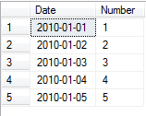

I created a Column chart and dragged over the date and numbers fields as shown.

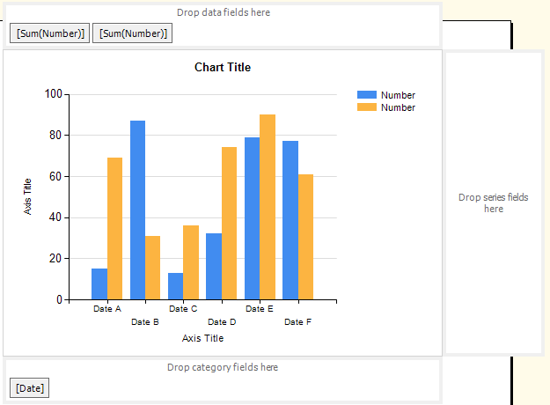

  Notice I placed the Number data in the data field twice. Then I right clicked on the data field and select the change chart type option. Then selected line chart.

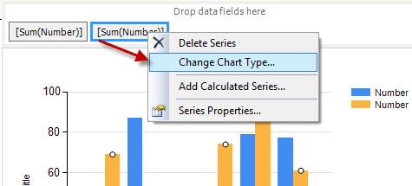

After I select line chart and click OK the chart looks like the image below. It now has columns and lines on the same chart.

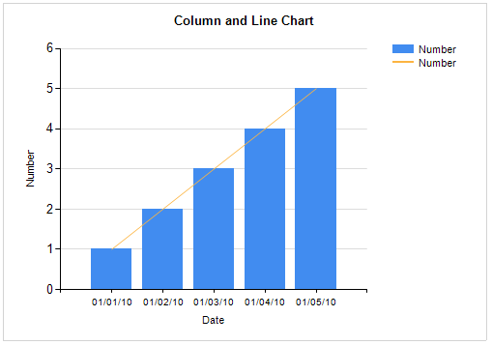

If you have multiple Series and only want to show for one series in the chart you will need alter the visibility. Here is the chart with a new columns I will use for the series.

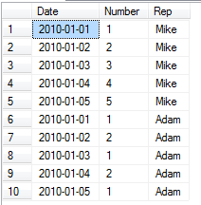

Refresh the data set and drag over the rep to the series field.

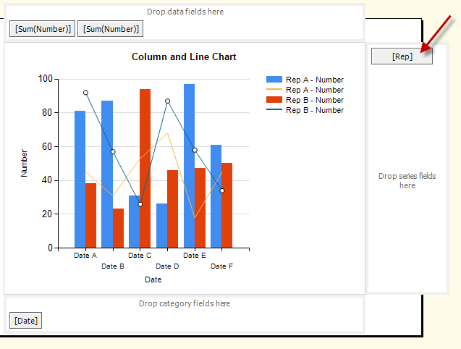

Right Click on the data field and go to series properties...

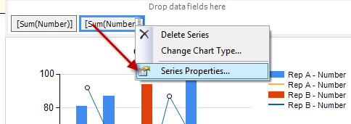

Then set the visibility expression. Remember to set it to **Not** equal to, this is setting who to hide, not who to show.

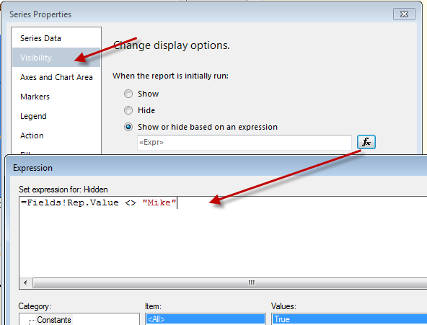

 The Chart will show multiple columns and a single line.

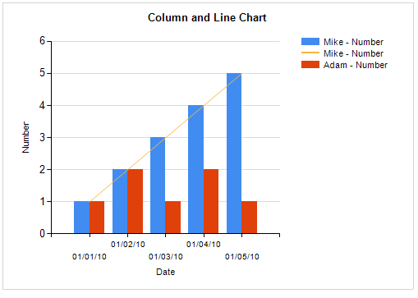

# SSRS Expressions

Reporting Services Expressions  
In Reporting Services, Expressions are used frequently in reports to control content and report appearance. Expressions are used throughout the report definition to specify or calculate values for parameters, queries, filters, report item properties, group and sort definitions, text box properties, bookmarks, document maps, dynamic page header and footer content, images, and dynamic data source definitions.

Expressions begin with an equal (=) and are written in Visual Basic.

Expressions can include a combination of constants, operators, and references to built-in values (fields, collections, and functions), and to external or custom code. Expressions can be one of the following two types:

* **Simple** - An expression that is a single reference to an item in a built-in collection, such as, a dataset field, a parameter, or a built-in field. Simple expressions appear on the design surface and in dialog boxes in brackets, such as [FieldName], which represents the underlying expression =Fields! FieldName.Value. You can type simple expressions directly into a text box on the design surface and the corresponding expression text is set as the value of a placeholder inside the text box.
* **Complex** - An expression that includes more than a simple reference. Complex expressions appear on the design surface as <>. You can create complex expressions in the Expression dialog box or type them directly into the Property pane.

### Examples of SSRS Expression

**Using Built-in Fields**

Display  Report Execution Time in a textbox:

="Report Execution Time: "&Globals!ExecutionTime

Display Page No in a textbox:  
="Page "&Globals!PageNumber&" of "&Globals!TotalPages

Similar way you can use other built-in Fields in expressions e.g. Report Folder, Report Name, ReportServerUrl, UserID, Language etc. as shown below:

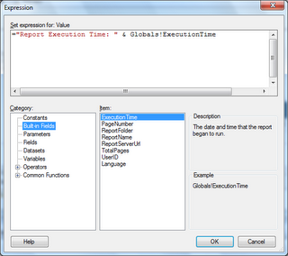

### Date & Time Functions

The **Today()** function provides the current date. The expression  =Today() can be used in a text box to display the date on the report, or in a parameter to filter data based on the current date. This function will return date in M/d/yyyy 12:00:00 AM format. You can use **Format** function to display required format. Some of the popular date formats are given below:

|  |  |
| --- | --- |
| **Expression** | **Output** |
| =FORMAT(Today(),"M/d/yy") | 8/23/10 |
| =FORMAT(Today(),"MM-dd-yyyy") | 08-23-2010 |
| =FORMAT(Today(),"MMM-dd-yyyy") | Aug-23-2010 |
| =FORMAT(Today(),"MMMM dd, yyyy") | August 23, 2010 |
| =FORMAT(DateField,"MMM dd, yyyyhh:mm:ss") | Aug 23, 2010 01:43:33 |
| =FORMAT(DateField,"MMM dd, yyyyHH:mm:ss") | Aug 23, 2010 13:43:33 |
| =FORMAT(DateField,"MMM dd, yyyyHH:mm:ss.fff") | Aug 23, 2010 13:43:33.587 |
| =FORMAT(DateField,"MMM dd, yyyyhh:mm:sstt") | Aug 23, 2010 01:43:33 PM |

Note: FormatDateTime function can also be used to format the date field e.g. =FormatDateTime(Fields!BirthDate.Value, DateFormat.ShortDate)

**DateAdd** - Returns a Date value containing a date and time value to which a specified time interval has been added. this function can be used in an expression to add/substract time(day, month, year, sec etc.) from given date field:   
=DateAdd(DateInterval.Month, 6, Parameters!StartDate.Value)

**DateDiff**- Returns a Long value specifying the number of time intervals between two Date values.   
=DateDiff("yyyy",Fields!BirthDate.Value,Today())

**DatePart** - Returns an Integer value containing the specified component of a given Date value.   
=DatePart("q",Fields!BirthDate.Value,0,0)  
  
=DatePart(DateInterval.Quarter,Fields!BirthDate.Value, FirstDayOfWeek.System, FirstWeekOfYear.System)

There are many other Date &Time functions which can be used expression:

[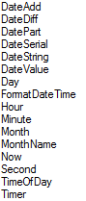](http://3.bp.blogspot.com/_2t15yG-FxQA/THLkyjKEDuI/AAAAAAAAA44/nicEZ332Pvc/s1600/1.png)

### String Functions

• Combine more than one field by using concatenation operators and Visual Basic constants. The following expression returns two fields, each on a separate line in the same text box:

=Fields!FirstName.Value&vbCrLf&Fields!LastName.Value

•Format dates and numbers in a string with the Format function.

=Format(Parameters!StartDate.Value, "M/D") &" through "& Format(Parameters!EndDate.Value, "M/D")

•The **Right**, **Len**, and **InStr** functions are useful for returning a substring, for example, trimming DOMAIN\username to just the user name. The following expression returns the part of the string to the right of a backslash (\) character from a parameter named User:

=Right(Parameters!User.Value, Len(Parameters!User.Value) - InStr(Parameters!User.Value, "\"))

The following expression results in the same value as the previous one, using members of the .NET Framework System.String class instead of Visual Basic functions:   
=User!UserID.Substring(User!UserID.IndexOf("\")+1, User!UserID.Length-User!UserID.IndexOf("\")-1)

• **Join** - Display the selected values from a multivalue parameter  
=Join(Parameters!MyParameter.Value,",")

•The **Regex** functions from the .NET Framework System.Text.RegularExpressions are useful for changing the format of existing strings, for example, formatting a telephone number. The following expression uses the Replace function to change the format of a ten-digit telephone number in a field from "nnn-nnn-nnnn" to "(nnn) nnn-nnnn":   
=System.Text.RegularExpressions.Regex.Replace(Fields!Phone.Value, "(\d{3})[ -.]*(\d{3})[ -.]*(\d{4})", "($1) $2-$3")

There are many other function which can be used in expression as shown below:  
[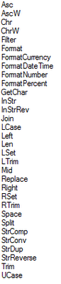](http://4.bp.blogspot.com/_2t15yG-FxQA/THLlp_lUagI/AAAAAAAAA5A/vayybAvgOoI/s1600/1.png)

**Conversion Functions**

You can use Visual Basic functions to convert a field from the one data type to a different data type.

The following expression converts the constant 100 to type Decimal in order to compare it to a Transact-SQL money data type in the Value field for a filter expression: =CDec(100)

The following expression displays the number of values selected for the multivalue parameter MyParameter: =CStr(Parameters!MyParameter.Count)

**Decision Functions**

The **IIF** function returns one of two values depending on whether the expression is true or false. The following expression uses the iif function to return a Boolean value of True if the value of Total exceeds 100. Otherwise it returns False:

=IIF(Fields!Total.Value> 100, True, False)

Use multiple IIF functions (nested IIFs) to return one of three values depending on the value of PercentComplete. The following expression can be placed in the fill color of a text box to change the background color depending on the value in the text box.

=IIF(Fields!PercentComplete.Value>= 10, "Green", IIF(Fields!PercentComplete.Value>= 1, "Blue", "Red"))

A different way to get the same functionality uses the **Switch** function. The Switch function is useful when you have three or more conditions to test. The Switch function returns the value associated with the first expression in a series that evaluates to true:

=Switch(Fields!PercentComplete.Value>= 10, "Green", Fields!PercentComplete.Value> 1, "Blue",

Fields!PercentComplete.Value = 1, "Yellow",

Fields!PercentComplete.Value<= 0, "Red",)

A third way to get the same functionality uses the **Choose** function. The Choose function uses the first parameter as an index to one of the remaining function parameters. The first parameter must be an integer. If the background color of a text box in a table is set to this expression, the value of MyIndex controls the color.

=Choose(Fields!MyIndex.Value,"Red","Green","Yellow")

Check the value of the PurchaseDate field and return "Red" if it is more than a week old, and "Blue" otherwise. This expression can be used to control the Color property of a text box in a report item:

=IIF(DateDiff("d",Fields!PurchaseDate.Value, Now())>7,"Red","Blue")

# Expressions and Custom code

In this section we will see how to write custom code expression and call it in the report.

### Example :

What we are going to do is that, if a player has made more than 500 runs and has taken more than 10 wickets, then we are going to display the row and the particular columns with green color.

For this, let us first click on the report design body and choose the report properties

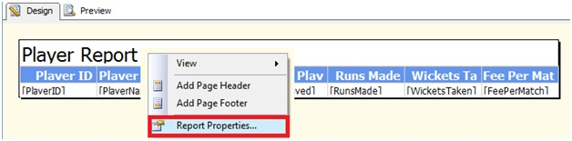

### Writing Custom Expression Code

The Report Properties window opens up as shown under

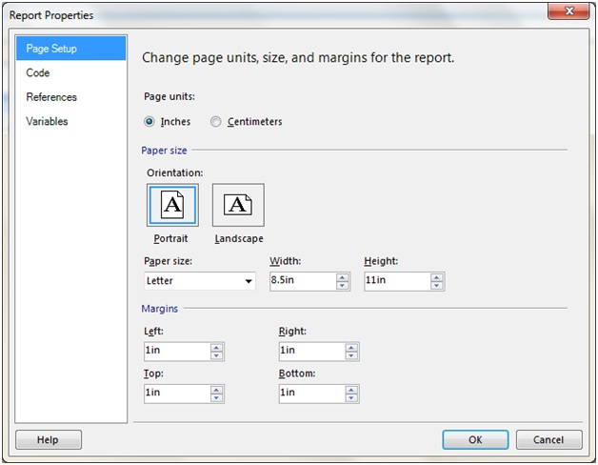

Navigate to the **Code tab** for writing the below custom code

Public Shared Function SetColor(ByValRunsMade As Integer,ByValWicketsTaken As Integer) As String

SetColor= "Transparent"

If RunsMade>= 500 ANDWicketsTaken>= 10 Then

SetColor= "Green"

End IF

End Function

The code is pretty simple to understand. We have declared a function by the name SetColor which accepts two integer variables,the first for the run and the next for the wickets taken. We set the initial value of the Setcolor to "Transparent”. Now if the condition meets, we will set the SetColor to "Green".

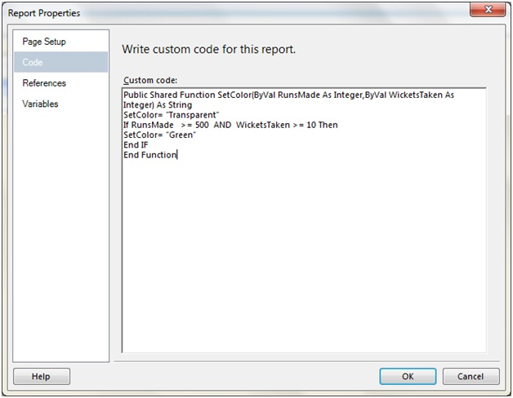

### Calling Custom Expression from Reports

Next let us choose the RunsMade column and right click to open the TextBox menu from which we will choose the TextBox Properties

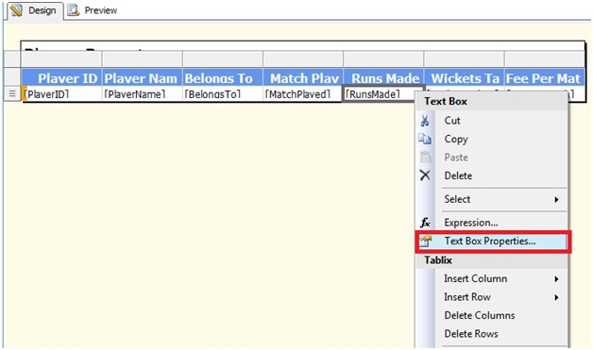

In the TextBox Properties window that appears, click on the Fill option and click the fx Button.

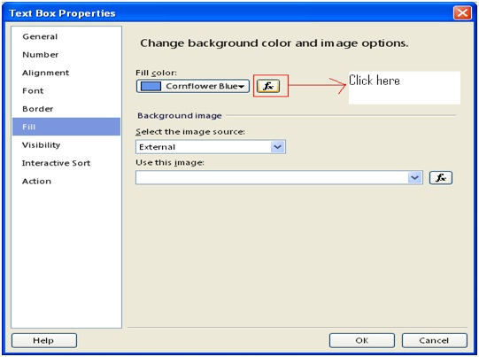

Enter the below expression in the Expression Window

=Code.SetColor(Fields!RunsMade.Value,Fields!WicketsTaken.Value)

Again the argument passing code snippet is very simple. In the first one, we are passing the RunsMade values while in the second we are passing the WicketsTaken values in the SetColor function that we just created.

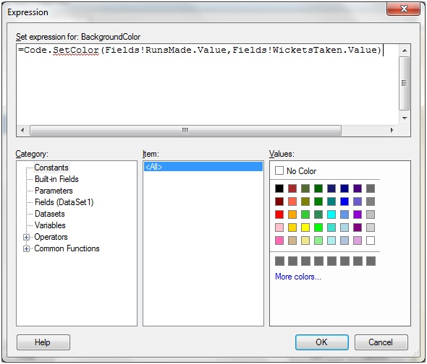

Click OK button and repeat the same for the Wickets Taken column. Once done, let us run the application and the result is as under

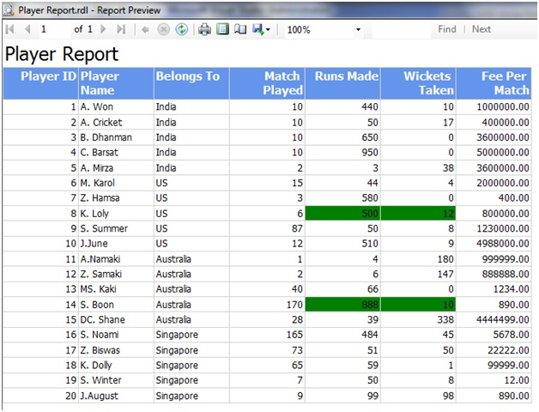

Let us add some more customization to our report. If the above criterion satisfies, we will make the Player Name value as bold and the Belongs to as Italic.

So let us add two more functions in the Custom Code as under.

**Function :SetBoldFontWeight**

' Function to set the font weight as bold

Public Shared Function SetBoldFontWeight(ByValRunsMade As Integer,ByValWicketsTaken As Integer) As String

SetBoldFontWeight= "Default"

If RunsMade>= 500 ANDWicketsTaken>= 10 Then

SetBoldFontWeight= "Bold"

End IF

End Function

**Function :SetItalicFontWeight**

'Function to set the font weight as italic

Public Shared Function SetItalicFontWeight(ByValRunsMade As Integer,ByValWicketsTaken As Integer) As String

SetItalicFontWeight= "Default"

If RunsMade>= 500 ANDWicketsTaken>= 10 Then

SetItalicFontWeight= "Italic"

End IF

End Function

The Custom Code area will now look as under

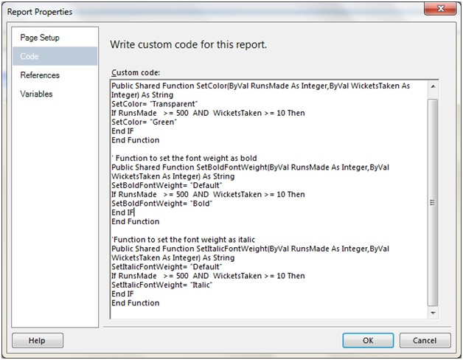

Next in the **PlayerName column** right click to bring the TextBox properties and from the Font option, choose the fn for Bold

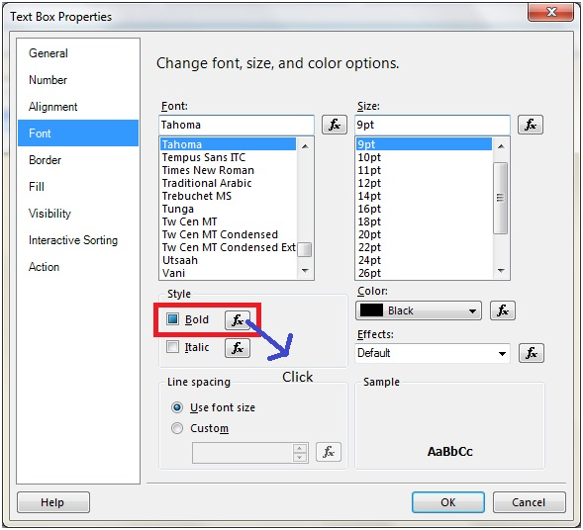

In the expression editor enter the below code

=Code.SetBoldFontWeight(Fields!RunsMade.Value,Fields!WicketsTaken.Value)

In the **Belongs To column** right click to bring the TextBox properties and from the Font option, choose the fx for Italic

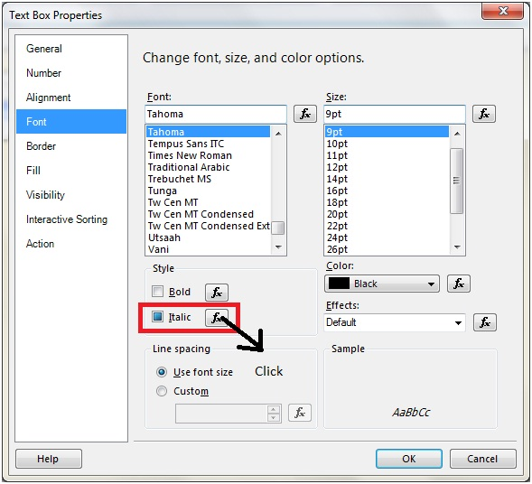

In the expression editor enter the below code

=Code.SetItalicFontWeight(Fields!RunsMade.Value,Fields!WicketsTaken.Value).

We are done. Run the report and the result is as under

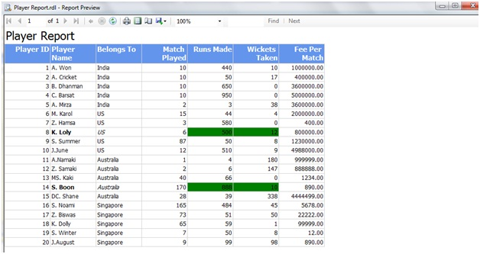

We will look into one more situation where we will generate alternate row color based on the **Player ID column**.

# Conditional Formatting Using Expression in SSRS

**Alternate Background Color in Tabular Report:**  
Alternate background color of rows in a table make it easier to read horizontally. Also it makes report look and feel better. This is very common but simple task to achieve in SSRS report using expression.  
  
Select the detail row of the data table in the layout tab.

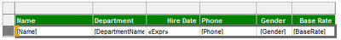

Go to property window and select expression of BackgroundColor and enter below expression:  
=IIF(RowNumber(Nothing) Mod 2 = 0,"Transparent","#cdfcbe")  
  
Now click and Preview the report:

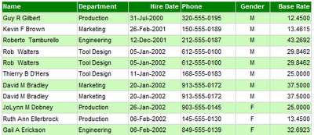

**Format Phone number using REGEX function:**  
Suppose you want to display Phone no in (ddd) ddd-dddd format instead of ddd-ddd-dddd. To do this, Right click on the required textbox --> click **expression...** and enter below expression:  
  
=System.Text.RegularExpressions.Regex.Replace(Fields!Phone.Value, "(\d{3})[ -.]*(\d{3})[ -.]*(\d{4})", "($1) $2-$3")  
  
  
Now click on Preview and see the report:

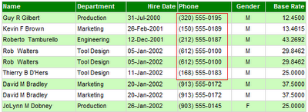

**Changing Font Color dynamically:**  
Sometime we need to format data based on the their values. Below is an example for Base rate color selection:

|  |  |
| --- | --- |
| **Base Rate** | **Color** |
| <= 15 | Green |
| > 15 AND <=25 | Blue |
| > 25 AND <=40 | Black |
| > 40 | Red |

To do this, Enter C (Currency format) in **Format** and below expression in **Color** property of **BaseRate**field:  
=SWITCH(Fields!BaseRate.Value<= 15,"Green",  
  
Fields!BaseRate.Value<= 25,"Blue",  
Fields!BaseRate.Value<= 40,"Black",  
Fields!BaseRate.Value> 40,"Red")  
  
Now click on Preview and see the report:

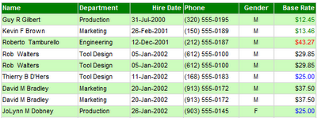

**Swapping Font Color and BackgroundColor:**  
Suppose you want to swap Font Color and BackgroundColor of Gender field. Use below expressions in BackgroundColor and Color properties respectively:  
  
=IIF(Fields!Gender.Value = "M","Tomato","Teal")  
  
=IIF(Fields!Gender.Value <>"M","Tomato","Teal")  
  
Now click on Preview and see the report:

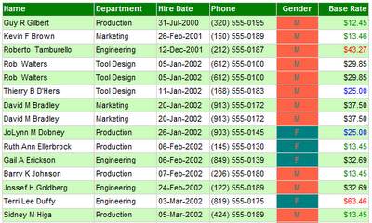

# Calculated Fields

A Calculated field is a field that is derived from another field.

**Function:**DoubleMatchFee

**Purpose:** Doubles the player match fees if the runs made by the Player are more than or equal to 500 and wickets taken are more than or equal to 10.

'Function to double the match fee

Public Shared Function DoubleMatchFee(ByValRunsMade As Integer,ByValWicketsTaken As Integer,ByValOriginalMatchFee As Integer) As Integer

DoubleMatchFee= OriginalMatchFee

If RunsMade>= 500 ANDWicketsTaken>= 10 Then

DoubleMatchFee= OriginalMatchFee * 2

End IF

End Function

Step 2: Choose Data Set. Right Click and choose Add Calculated field

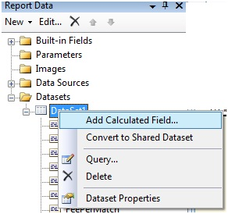

The DataSet Properties window opens up. Enter a Calculated field Name and click on the Expression button (fx)

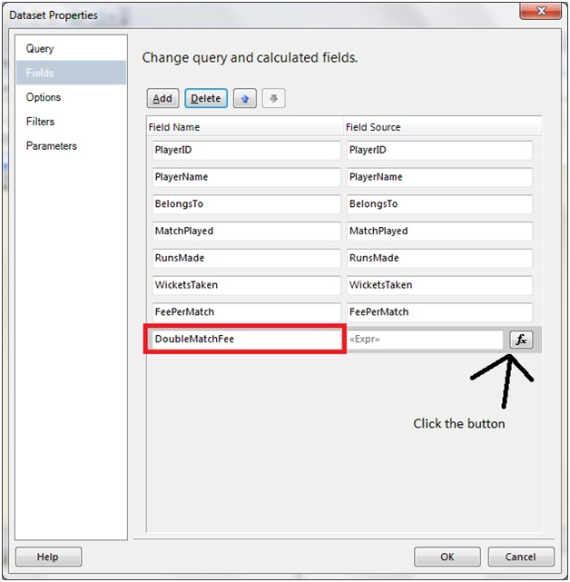

Next Add the below expression in the expression window

=Code.DoubleMatchFee(Fields!RunsMade.Value,Fields!WicketsTaken.Value,Fields!FeePerMatch.Value)

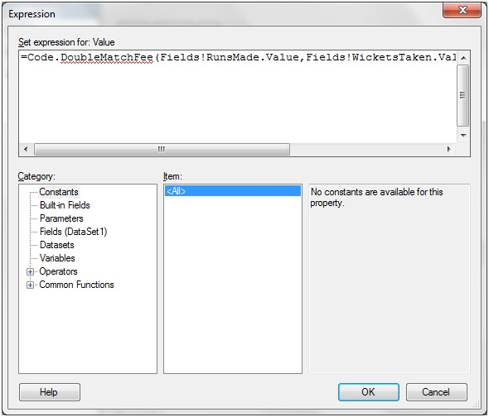

Click OK.

Step 3: Drag and drop the DoubleMatchFee column to the Report Designer.

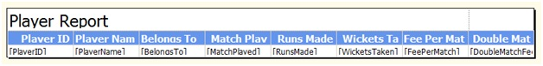

# Lab Example [Writing Custom Code for Expressions]

Suppose we want to twice the match fee for every player who ever has bagged more than 10 wickets and made a score of more than 500 runs. In such a case, that row will be will be green colored and the Calculated column value will be made bold.

**Solution**

Step 1: As a first step let us write the custom codes

**Function:**SetColor

**Purpose:** This function will set the color for the entire row to green if the runs made are more than or equals to 500 and wickets taken are more than or equals to 10.

'Function to set the color

Public Shared Function SetColor(ByValRunsMade As Integer,ByValWicketsTaken As Integer) As String

SetColor= "Transparent"

If RunsMade>= 500 ANDWicketsTaken>= 10 Then

SetColor= "Green"

End IF

End Function

**Function:**SetBoldFontWeight

**Purpose:** This function will set the Row data to Bold for the Calculated column where the runs made by the Player are more than or equal to 500 and wickets taken are more than or equal to 10.

' Function to set the font weight as bold

Public Shared Function SetBoldFontWeight(ByValRunsMade As Integer,ByValWicketsTaken As Integer) As String

SetBoldFontWeight= "Default"

If RunsMade>= 500 ANDWicketsTaken>= 10 Then

SetBoldFontWeight= "Bold"

End IF

End Function

# Drilldown Report in SSIS

Creating a drill down / Tree view report in SSRs is very simple.Let us see the following steps to do so.

Step 1: Open BIDS and create a new Shared Data Source

Step 2: Create a Table type report as shown below (The steps for doing so has been described in Part I series).

e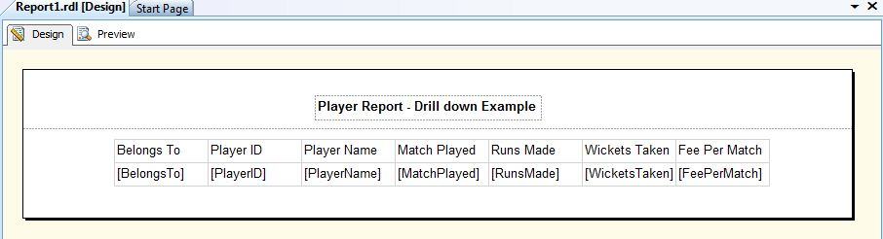

Step3: Next add **Parent Group** for **BelongssTo** field as depicted under

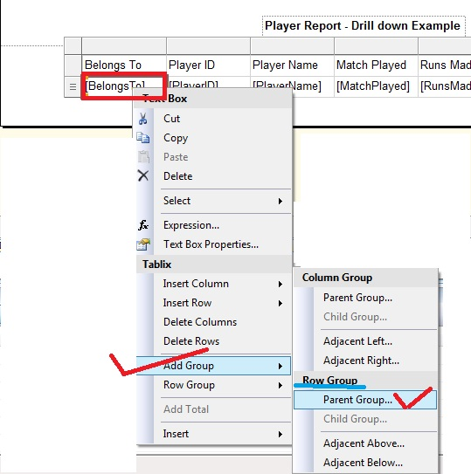

Step 4: From the **Tablix Group** window, let us choose **[BelongsTo]** from Group ByDropDown and *check Add Group Header checkbox*, then click OK.

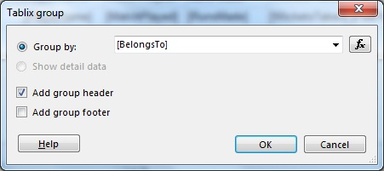

At this point if we the report looks as under in the design view

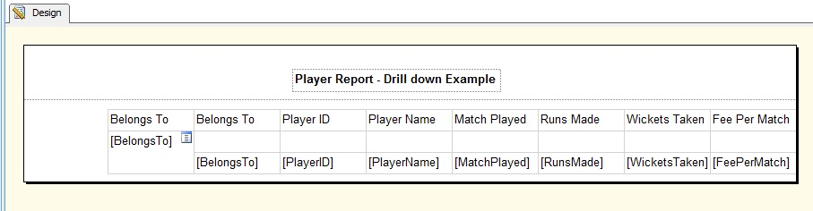

While running the report gives the below impression in the Preview tab

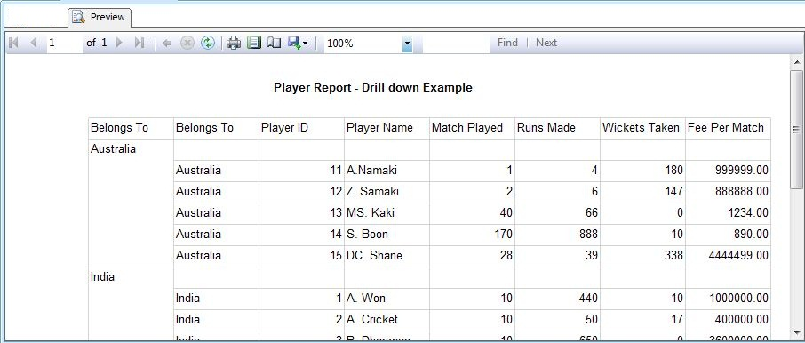

Step 5: From Row groups, choose **[Belongs To] Details** and then choose **Group Properties**

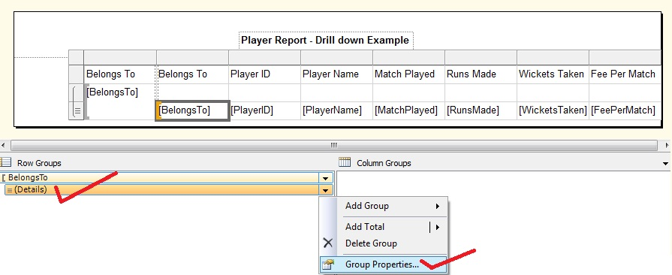

Step 6: From the Group Properties window that opens up, choose Visibility tab. Then select **Hide radio button** and check the **Display can be toggled by this report item** checkbox.Then from the drop down that will be enable,select the name of the group (which is BelongsTo1 here) then click on OK

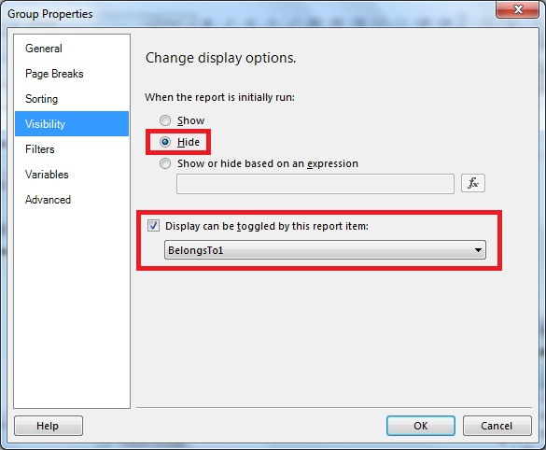

Step 7: Delete the [Belongs To] Details column

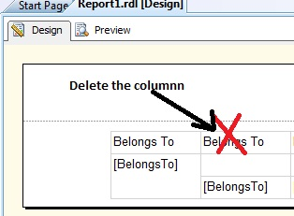

Step 8: Now it's all done. Run the application and the output is as under

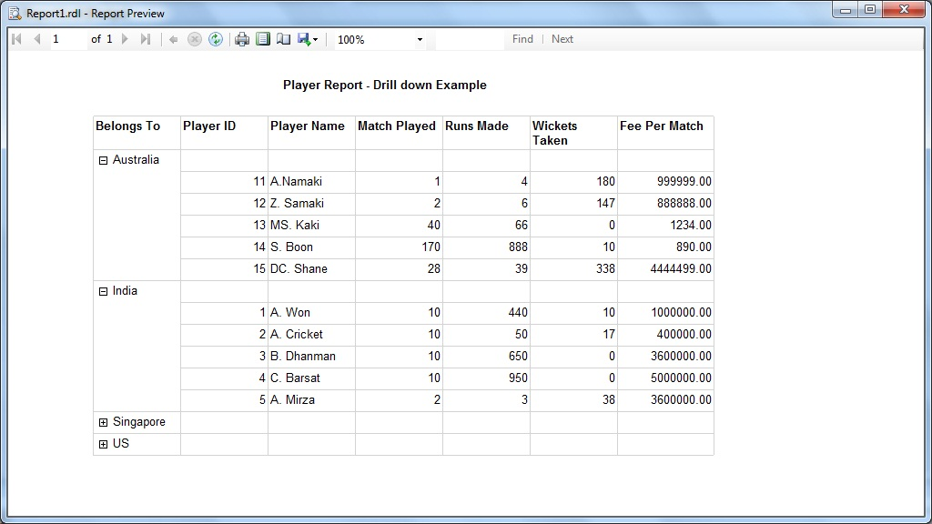

## DRILL DOWN IN CHARTS

How to create Drill Down Chart Report in SSRS.

1. First of all open Visual Studio 2010 and open your SSRS project. Then add report named as **YearWiseSales** in your project.

Now create a Dataset. In the dataset, we will use following query :

SELECT DATEPART(Year, SOH.OrderDate) AS OrderYear,

ROUND(SUM(SOD.LineTotal),2) AS SalesFROM Sales.SalesOrderHeader SOH

INNER JOIN Sales.SalesOrderDetail SOD ON SOH.SalesOrderID = SOD.SalesOrderID

|  |  |
| --- | --- |
| GROUP BY DATEPART(Year, OH.OrderDate)ORDER BY DATEPART(Year, OH.OrderDate) |  |
|  |  |

Right click on report area and go to **Insert**–>**Chart**.& select **Column** from window. Then click on OK button.

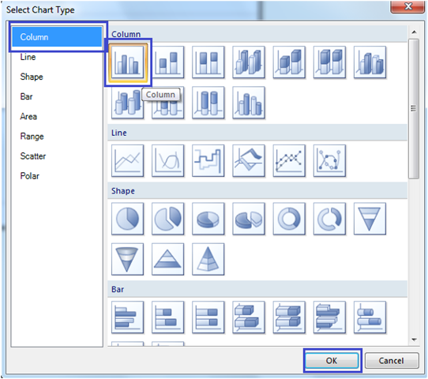

Now in Chart Data select **OrderYear** in Category Groups &**Sales** in Values.To enable 3D effects, right click on chart and Check checkbox of **Enable 3D**.Then click on OK button.

[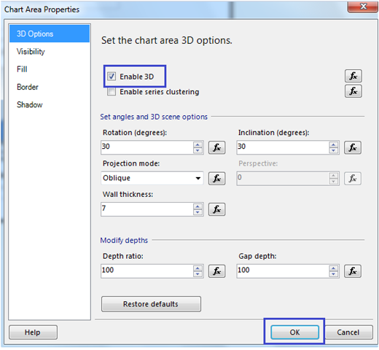](http://bhushan.extreme-advice.com/wp-content/uploads/2012/11/3-Drill-Down-Chart-Report-in-SSRS.png)

Also give proper description to Chart Title & Axis Titles. Now your report design looks like below :

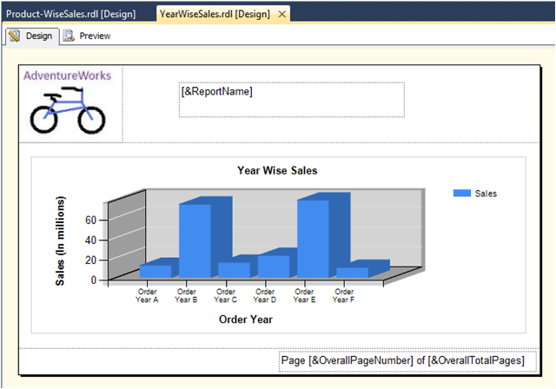

Now create another report named as **ProductWiseSales**. then create a Dataset. In the dataset, we will used following query :

|  |  |
| --- | --- |
|  | SELECT      PC.NameASProdCat, SUM(SOD.LineTotal) ASSales  FROM        Sales.SalesOrderHeader ASSOH  INNERJOIN  Sales.SalesOrderDetail ASSOD ONSOH.SalesOrderID = SOD.SalesOrderID INNERJOIN  Production.Product ASP ONSOD.ProductID = P.ProductID INNERJOIN  Production.ProductSubcategory ASPS ONP.ProductSubcategoryID = PS.ProductSubcategoryID INNERJOIN  Production.ProductCategory ASPC ONPS.ProductCategoryID = PC.ProductCategoryID WHERE       DATEPART(Year, SOH.OrderDate) = @YEARGROUPBY    PC.NameORDERBY    PC.Name |

5. Now right click on report area and go to **Insert**–>**Chart**.& select **3-D Expleded Pie** from window. Then click on OK 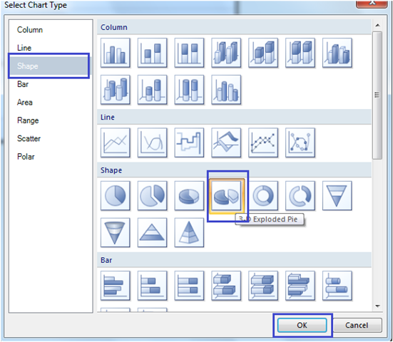

6. Now in Chart Data select **ProdCat** in Category Groups &**Sales** in Values. Now your report design looks like below 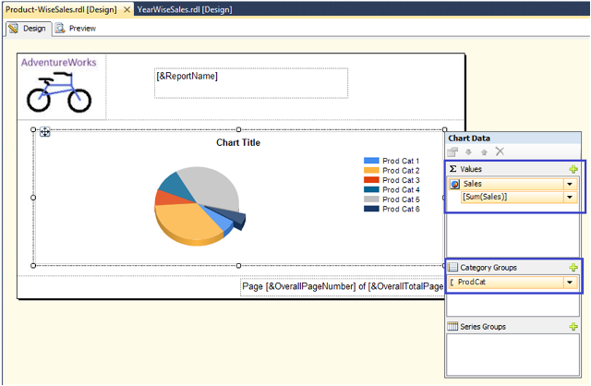

7. If you want to add title on Legend, Right click on legend and select **Show Legend Title**.

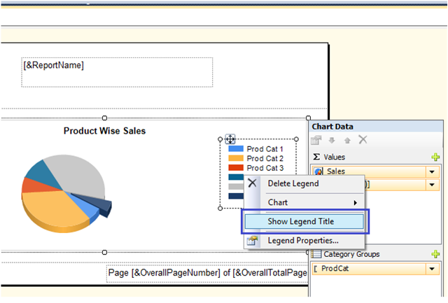

Give Title like **Product Wise Sales (In Millions).**Also give Proper Chart Title.

8. Now Open first report i.e. **YearWiseSales.** Right click on Series & select Series Properties.

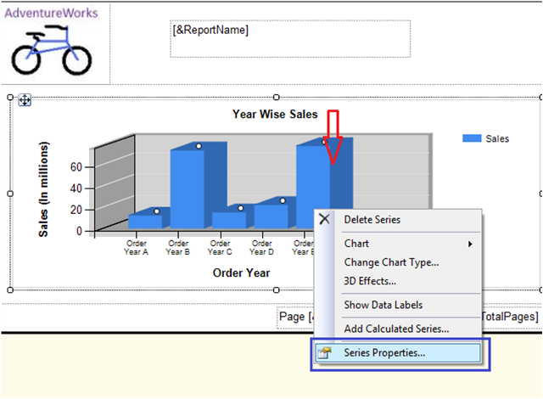

9. A Series Properties window pops-up. Select Action from left pane.Then select **Go to report**. Then select report from dropdown list of **Specify a report (**i.e.**ProductWiseSales)**.

Then Add **parameter**& select value from dropdown list of value. then click on Ok button.

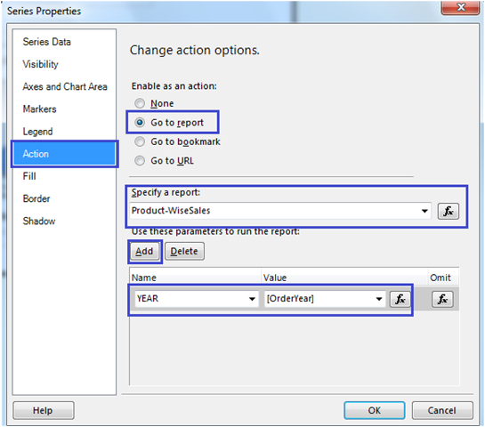

10. So we have done with our drill down chart report. To see the results click on preview tab.

Your results looks like below :

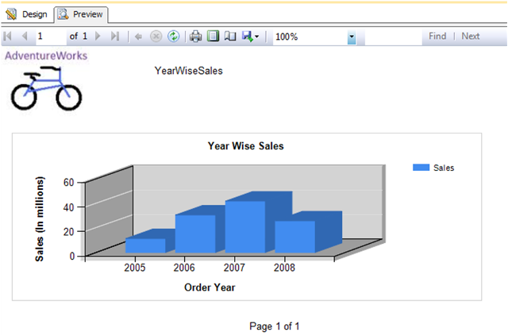

To see the year wise result click on the data bar of year.

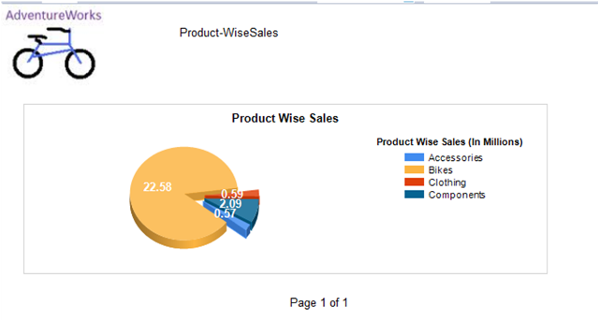

Congratulations! We successfully completed Drill Down Chart Report in SSRS.

# SUBREPORTS

StudentMainReport.rdl

SELECT * FROM STUDENT

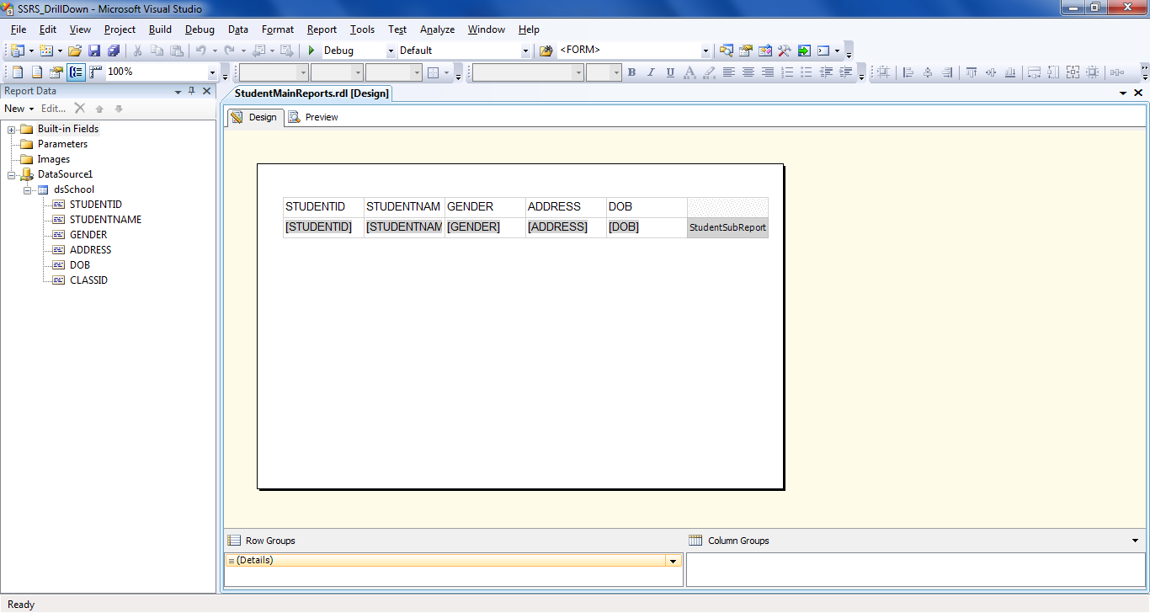

StudentSubReport.rdl

SELECT * FROM STUDENTMARKS WHERE STUDENTID=@STUDENTID

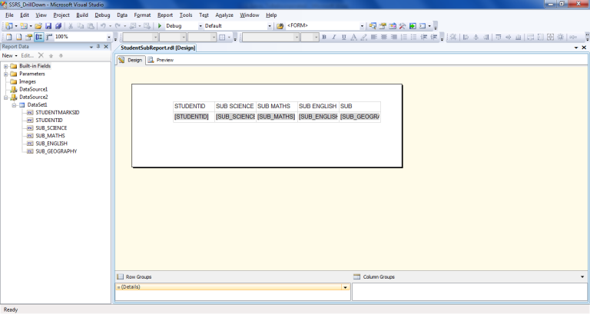

In StudentMainReport.rdl

# 

Insert SubReport in StudentMainReport.rdl,

Right Click SubReport Control in StudentMainReport.rdl and in the General Section , in the combobox select the subreport : StudentSubReport.rdl

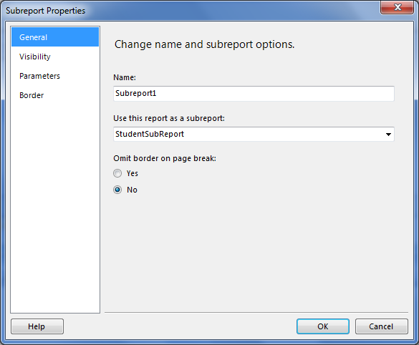

In the SubReport: Parameters Click on “ADD” and select “STUDENTID”

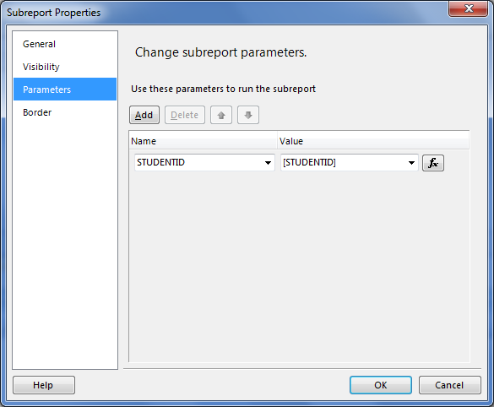

# Sorting of Columns

In this section we will look into how to perform sorting of columns in the report. Column sorting is an important feature and it can be done from the database side also. But if the same data source is being use by various other application and each demands the result to be displayed in different order, then it is better to do the sorting in the client applications only as opposed to the database.

Step 1: Right click on the column header and choose Textbox Properties.

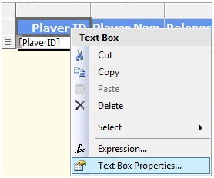

Step 2: Choose Interactive Sort from the Textbox properties dialog and

1. Check the checkbox for Enable interactive sort on this Textbox
2. Choose Player ID field from the Sort by drop down.

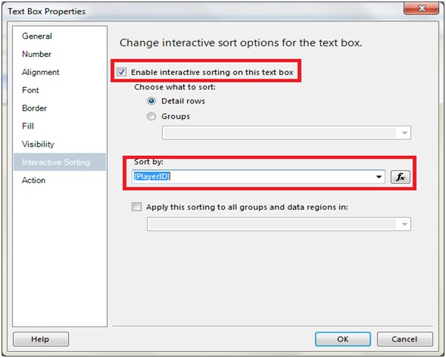

And we are done. Let us perform the same for PlayerNamefield.Now run the report

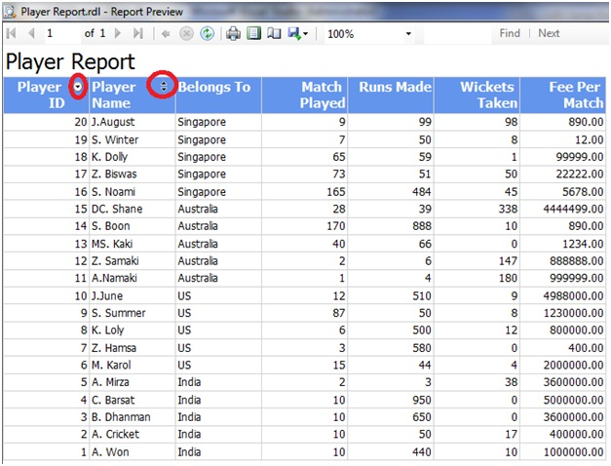

As can be seen that the sorting has been enabled on two columns and the report is presented in descending order of Player ID.

# Paging in SSRS report

This section will give us the way of generating custom paging in our report. We will also learn the use of Global variable in doing so.

Step 1: In the report design screen, right click and from the context menu, choose Add Page Footer

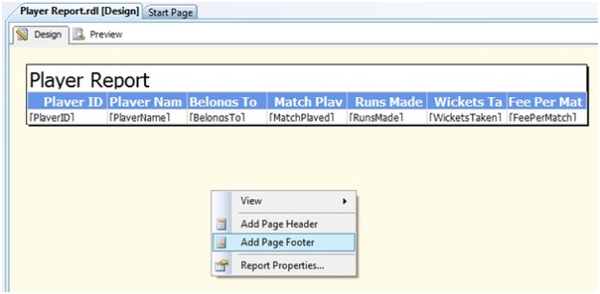

Once the Page Footer is added, we can then add controls to it.

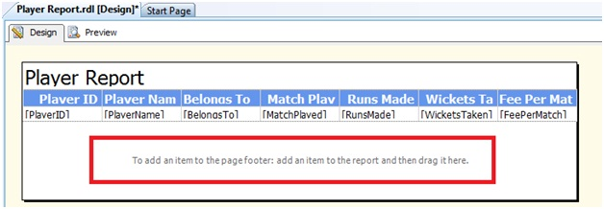

Step 2: Let us add four textboxes from the Report Item toolbox onto the designer as shown under

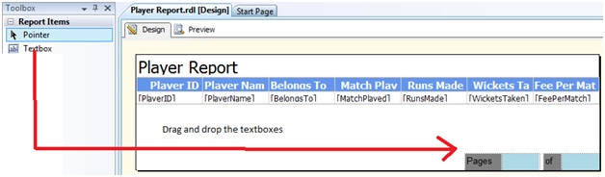

Step 3: Choose the 2nd textbox and click on the Expression

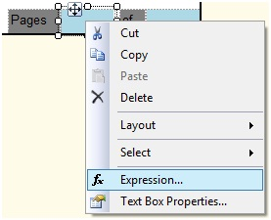

Step 4: From the expression window that opens, let us write the expression

=Globals!PageNumber

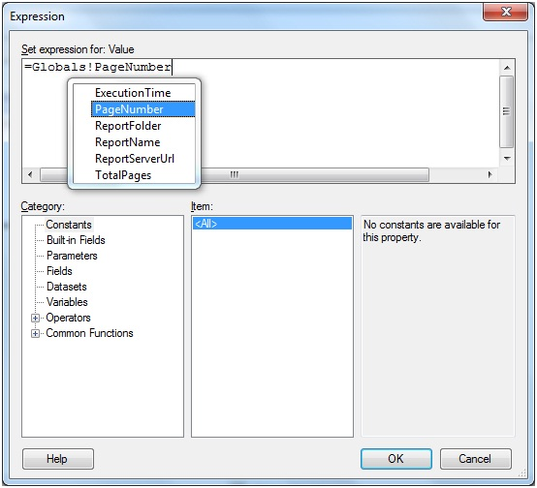

Similarly for the 4th Textbox, let us write the expression as **=Globals!TotalPages.**

Step 5: Run the report and the output is as under

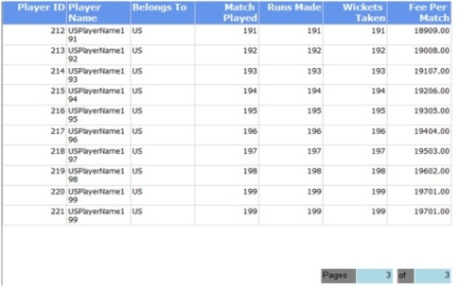

# DEPLOYMENT

## Sql Server 2012 Reporting Service Configuration Manager

Please go through following steps:

1. In the start menu go to Microsoft Sql Server 2012 R2 -> Configuration Tools, and then click **Reporting Service Configuration Manger.**

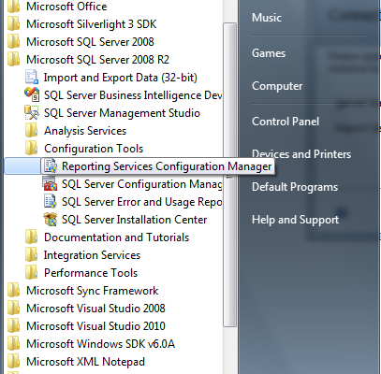

 2. In **Reporting Service Configuration Connection,** Select or Enter **Server Name** and **Report Server Instance**, then click on Connect.

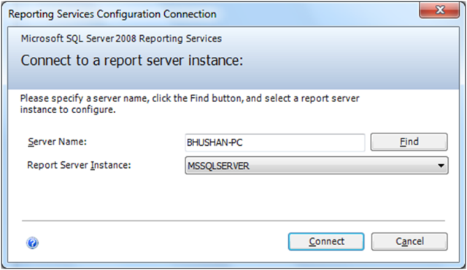

The Server will be the name of the Server.

The Report Server Instance will be the name of the database Instance to which the report server will be connecting.

3. In **Report Server Status** verify that the Service Status is set to Running. If it is not started, click on Start, and then click on Apply.

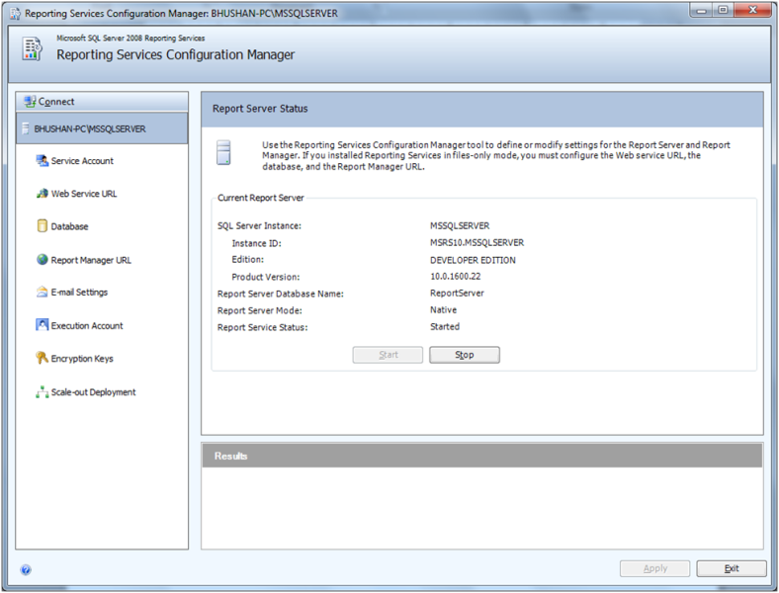

The Server needs to be started and the service needs to be running. It defines whether you want the report server to the started or stopped.

4. In **Service Account** Pane, you can set service account like **Local System,** if you want it to run only in local system or **Network Service,** if you want it to run on your Network.

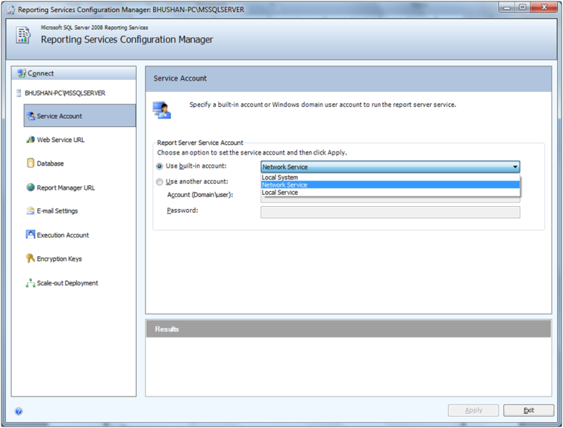

5. In **Web Service URL** Pane, specify the name which you want to call the virtual directory created by Reporting Services or you can use the default Report Server or you can select the IP-address, the port and SSL setting you want to use. When done click on Apply.

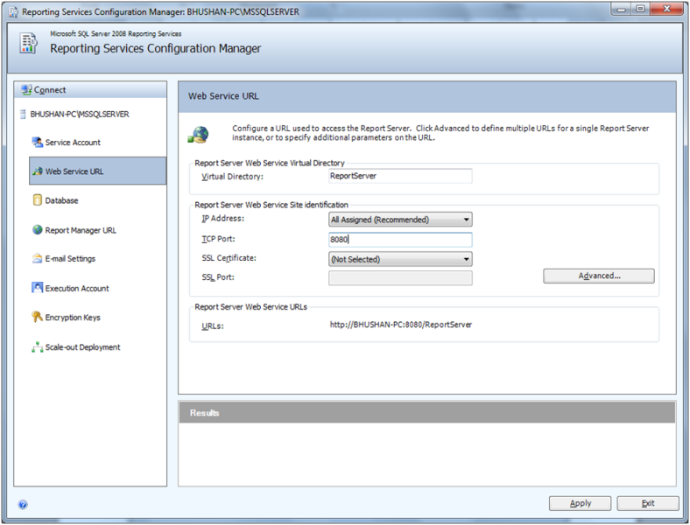

6. In **Database** Pane, select existing Report Server Database or You can also create a new Report Server Database.

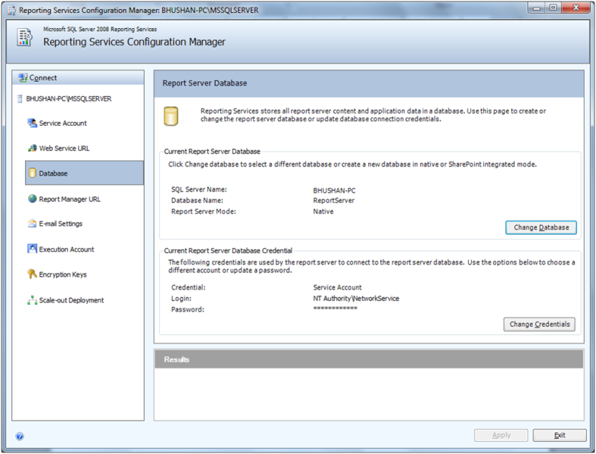

The Report Server Database will be database used while deploying the database. The database name can also be changed.

7. In **Report Manager URL** Pane, specify the name which you want to call the virtual directory created by Reporting Services or you can use the default Report Server or you can select the IP-address, the port and SSL setting you want to use. When done click on Apply.

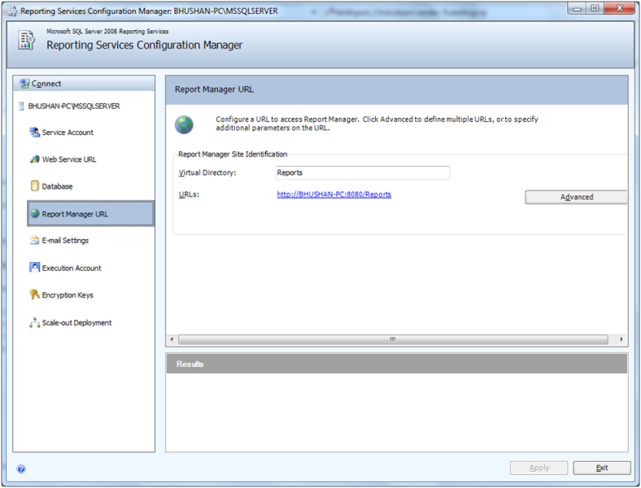

8. **Email settings** are not mandatory but you can configure if it is necessary for you.

9. **Execution Account** is necessary to configure if you will be running unattended reports. Optionally apply credentials and Click Apply.

## Deploy SSRS Report Server Project

To deploy Report Server Project, please go through below steps:

1. Go to Report Service Configuration Manager then click on the Report Manager URL tab in order to get Report Server URL.

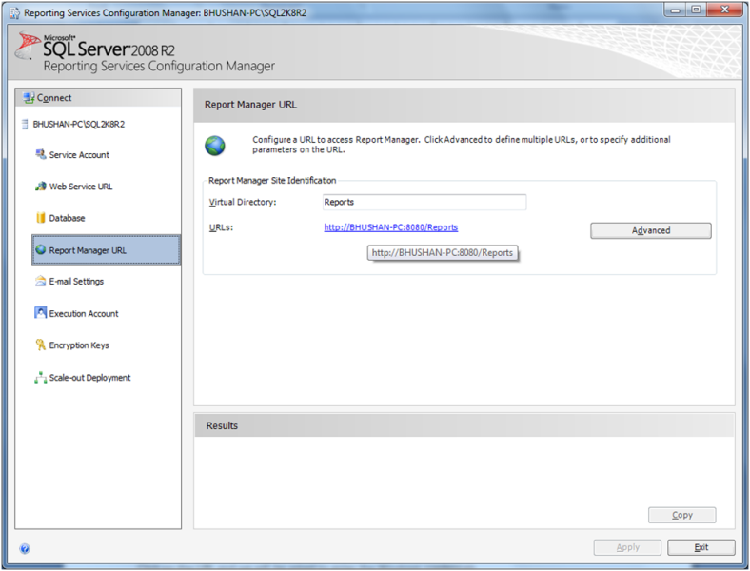

2. Now click on the Report Manager URL. We will get a empty screen as below:

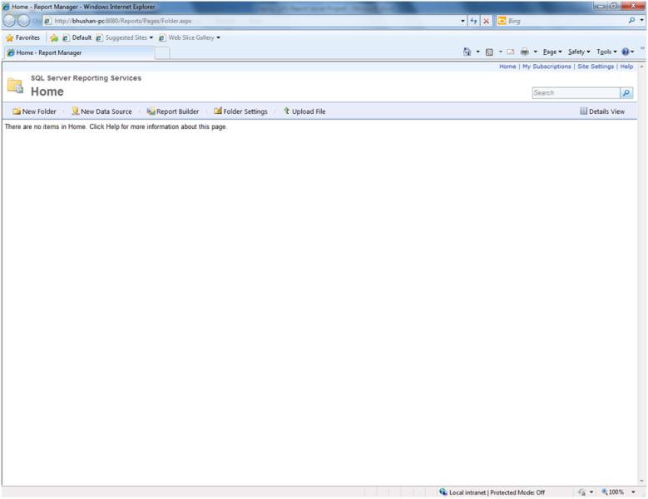

3. Let us query catalog table of ReportServer Database.

**SELECT * FROM CATALOG**

It will show below output:

[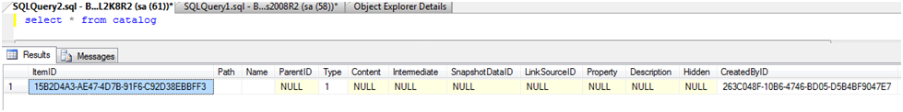](http://bhushan.extreme-advice.com/wp-content/uploads/2012/10/Deploy-SSRS-Report-Server-Project-3.png)

When we design a report, Report Definition Language File (.rdl) is generated which is basically a XML file which contains all the information about our report. So when we deploy the report, the .rdl file gets inserted into the our Report Server Database.

4. Now come back to our SSRS Project. Right Click the **Project** and click on **properties**.

[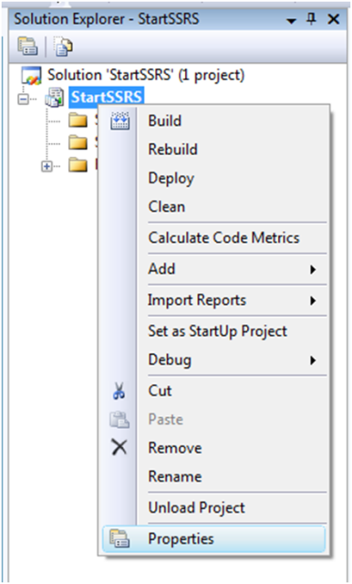](http://bhushan.extreme-advice.com/wp-content/uploads/2012/10/Deploy-SSRS-Report-Server-Project-4-1.png)

Alternatively we can also go from Project Menu.

[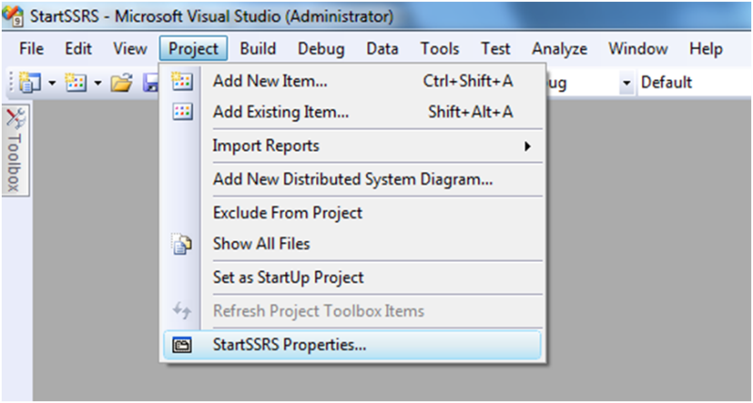](http://bhushan.extreme-advice.com/wp-content/uploads/2012/10/Deploy-SSRS-Report-Server-Project-4-2.png)

5. In both case we will be directed to **Project’s Properties** Page where we are going to insert our **Target Server URL** which is our Report Server Web Service URL.

In my case it is like

**http://bhushan-pc:8080/ReportServer**

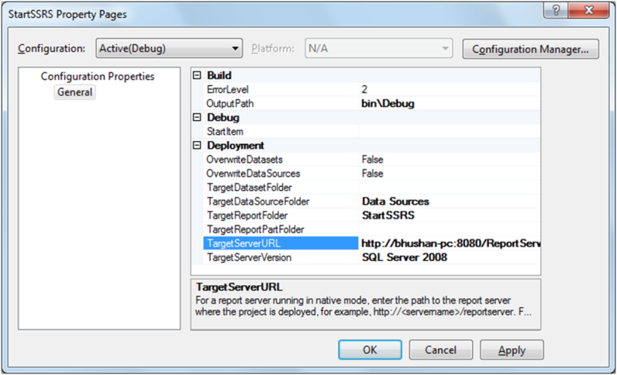

6. After click on OK, right click the Project and select Deploy from the context menu.

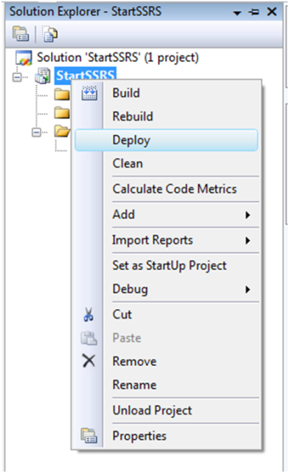

7. If all fine we will receive Success Message.

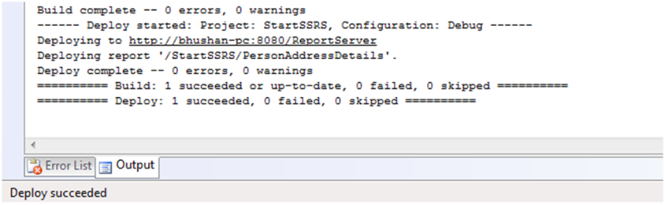

8. If here we query our Catalog table of Report Server database we will get results like following.

**SELECT * FROM CATALOG**

[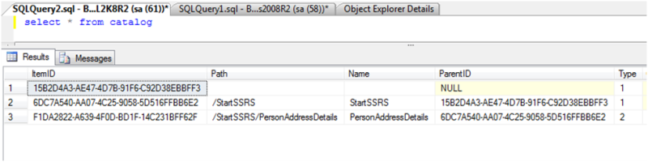](http://bhushan.extreme-advice.com/wp-content/uploads/2012/10/Deploy-SSRS-Report-Server-Project-8.png)

Here we can see the entries of Our Project and Report.In above result Type 1 means Project and 2 means Report.

If you want to see the XML content, execute following query:

SELECT [REPORT NAME] = NAME,[RDL CONTENT] = CAST(CAST(CONTENT AS VARBINARY(MAX)) AS XML)  
FROM CATALOG WHERE TYPE = 2

You will get results like following:

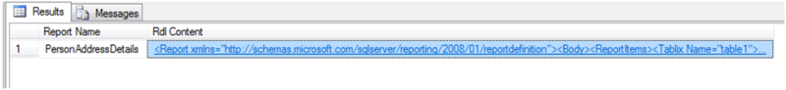

9. Now let us see our report from the browser.Go to Report Manager URL and you will get a screen like below:

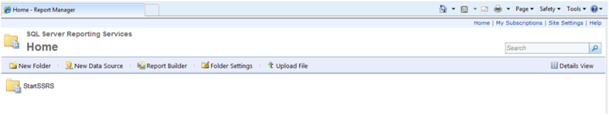

10. Now click on StartSSRS and it will show the list of report.In our case it will show only 1 report which is PersonAddresDetails.

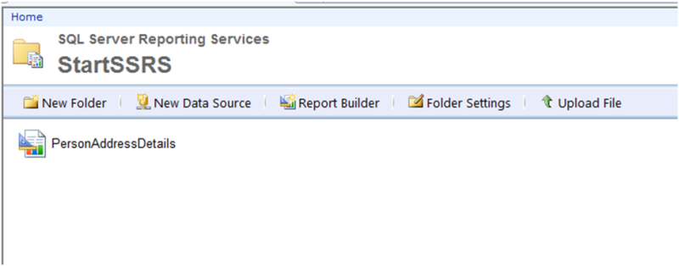

11. Now Click on PersonAddresDetails Report and you will get following screen:

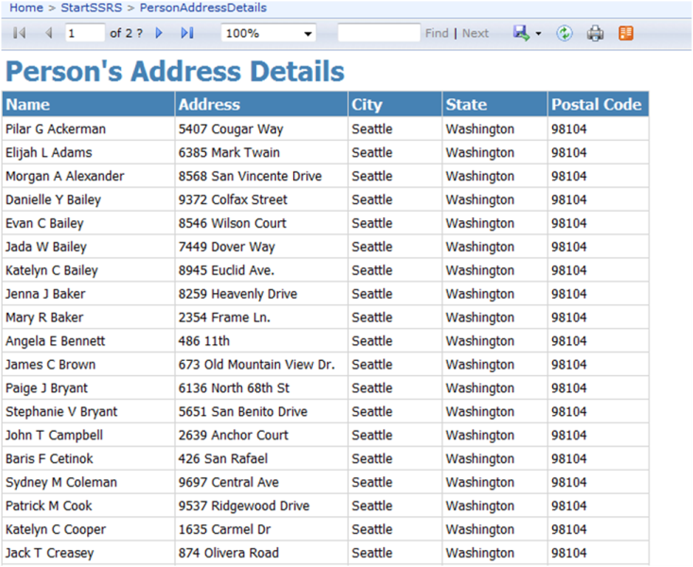

Congratulations! Our First SSRS Project is successfully deployed.

## UPLOADING REPORTS USING REPORT MANAGER

To begin navigate to the Report Manager home by opening your browser and typing in the URL; e.g. [http://SERVERNAME/reports](http://servername/reports), where SERVERNAME is the server where the Report manager is deployed.

If you are working in your development environment and allowed the SQL Server installer to install and configure Reporting Services then you can use localhost as your SERVERNAME.

After navigating to the Report Manager home you will see the following:

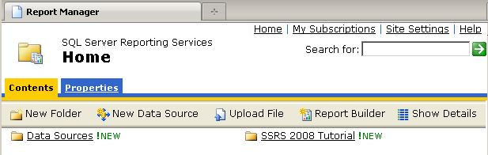

Click the Upload File button to deploy a report.  Fill in the dialog as shown below by navigating to the report that you want to deploy.  I navigated to the folder where our BIDS project was saved and picked the file ReportDesignerExample.rdl (reports are stored in XML files with a .RDL extension):

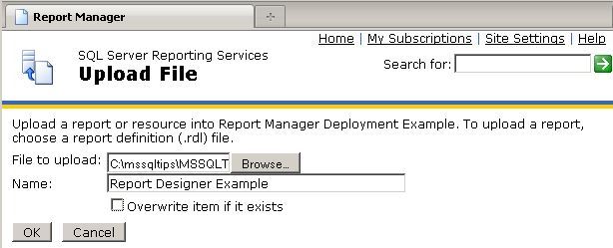

After clicking OK to deploy the report, you can click on the report in the Report Manager to render it as shown below:

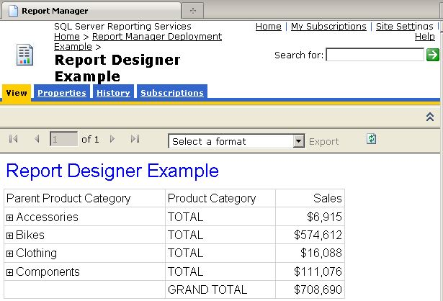

## User Roles and Permissions in SSRS

To create User Roles and assign roles & permissions to users in SSRS.

**The Browser Role**: The Browser role is the basic role assigned to users who are going to view reports. The Browser role has rights to perform the following tasks:

* Manage individual subscriptions
* View folders
* View models
* View reports
* View resources

**The Publisher Role** The*Publisher* role is assigned to users who are going to create folders and upload reports. The Publisher role has rights to perform the following tasks:

* Create linked reports
* Manage data sources
* Manage folders
* Manage models
* Manage reports
* Manage resources

**The Reports Role** The*My Reports* role is designed to be used only with a special folder called the My Reports folder. Within this folder, the My Reports role gives the user rights to do everything except change security settings. The My Reports role has rights to perform the following tasks:

* Create linked reports
* Manage data sources
* Manage folders
* Manage individual subscriptions
* Manage report history
* Manage reports
* Manage resources
* View data sources
* View folders
* View reports
* View resources

**The Content Manager Role** The*Content Manager* role is assigned to users who are managing the folders, reports, and resources. All members of the Windows local administrators group on the computer hosting the report server are automatically members of the Content Manager role for all folders, reports, and resources. The Content Manager has rights to perform all tasks, excluding system-wide tasks.

**The System User Role** The system-wide security tasks have two predefined roles.The*System User* role has rights to perform the following system-wide tasks:

* Execute report definitions
* View report server properties
* View shared schedules

**The System Administrator Role** The*System Administrator* role provides the user with rights to complete any of the tasks necessary to manage the report server. All members of the Windows local administrators group on the computer hosting the report server are automatically members of the System Administrator role. This role has rights to perform the following system-wide tasks:

* Execute report definitions
* Manage jobs
* Manage report server properties
* Manage report server security
* Manage roles
* Manage shared schedules

1. First of all open Internet Explorer and go to Report Manager URL which is something like below:

**http://enosis-pc/Reports2012**

Your browser tab looks like below :

[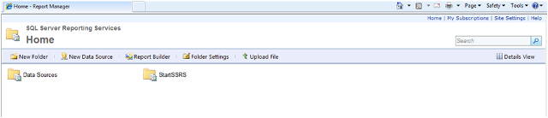](http://bhushan.extreme-advice.com/wp-content/uploads/2012/12/1-User-Roles-and-Permissions-in-SSRS.png)

2. Now click on the link of **Site Settings** which is on the right top corner. Then click on the **Security** from the left pane. You will see results like below.

[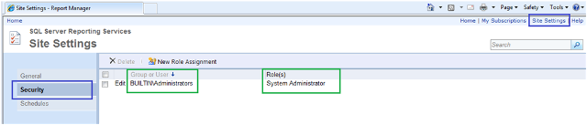](http://bhushan.extreme-advice.com/wp-content/uploads/2012/12/2-User-Roles-and-Permissions-in-SSRS.png)

Here you will see **BUILTIN\Administrators** user assigned to **System Administrator** role.

3.To add New Role Assignment, click on the link of **New Role Assignment** as Shown in below screenshot.

[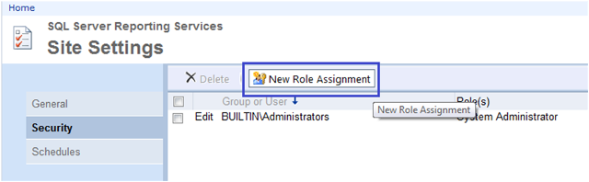](http://bhushan.extreme-advice.com/wp-content/uploads/2012/12/3-User-Roles-and-Permissions-in-SSRS.png)

4. In next screen, Enter the Group or User Name and select role based on your requirement. Please see below screenshot.

[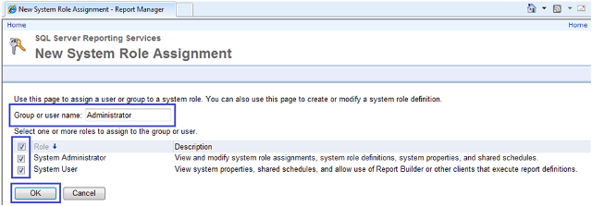](http://bhushan.extreme-advice.com/wp-content/uploads/2012/12/4-User-Roles-and-Permissions-in-SSRS.png)

Then click on OK button. Here you can see the list of Roles which are assigned to group or users.

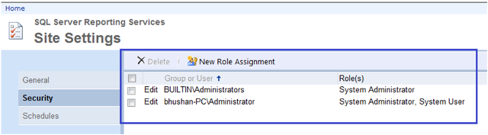

5. Now click on the link of Home and then click on the link of Folder Settings.

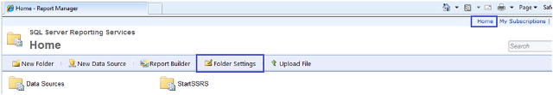

6. You will see results like following.

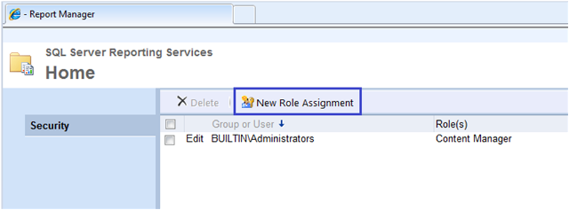

7. Then click on New Role Assignment and you will see like below screenshot.

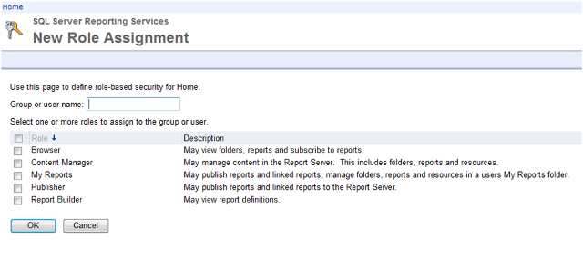

In that screen Enter group or user name and select roles as par your requirement.Here we will add Administrator and assign roles of Content Manager & My Reports. Then click on OK button.

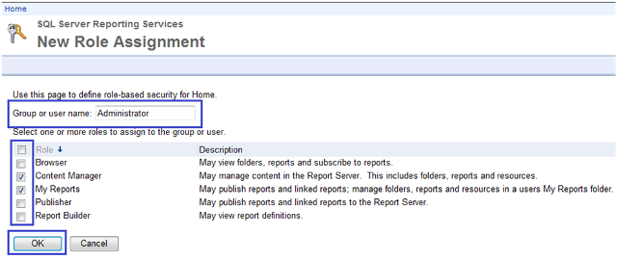

Here you can see added role.

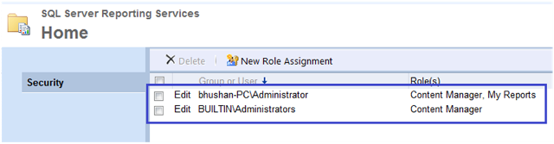

Congratulations! We successfully created User Roles and Permissions in SSRS.

# SSRS Integration with ASP.Net

# Invoking the deployed report from Asp.net.

The html code is as under

<body>

<form id="form1" runat="server">

<table>

<tr>

<td>

<asp:Button ID="btnShowReport" runat="server" Text="Display Report" Font-Bold="True" />

</td>

</tr>

<tr>

<td>

<rsweb:ReportViewer ID="repViewer" runat="server" Width="1044px" Height="488px" />

</td>

</tr>

</table>

</form>

</body>

And the design looks as under

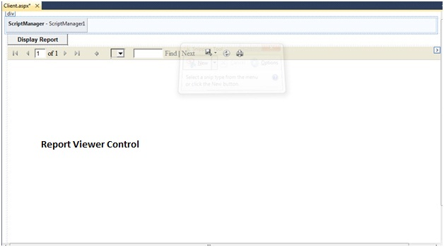

Step 3:Now let us double click on the button and add the below code in the code behind of the Button click event

try

{

repViewer.ProcessingMode =Microsoft.Reporting.WebForms.ProcessingMode.Remote;

repViewer.ServerReport.ReportServerUrl = new Uri("http://localhost/ReportServer ");

repViewer.ServerReport.ReportPath = "/BasicSSRSReport /Player Report";

repViewer.ServerReport.Refresh();

}

catch (Exception ex)

{

throw ex;

}

Our player report is located in the **BasicSSRSReport_Part1/Player Report** path in the server.

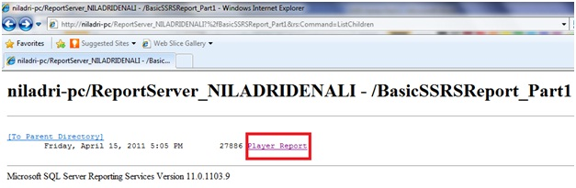

Anyways, now run the application and on Display Report button click we will get the report as under

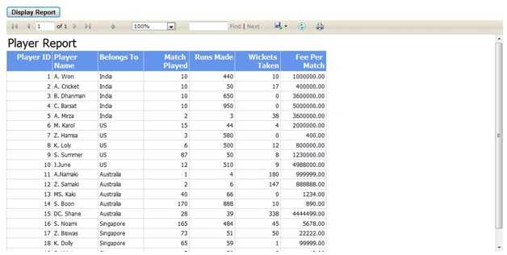

So, in this section we learnt how to invoke the report which is deployed in the server through the client.

# CALLING SSRS REPORTS WITH PARAMETERS

 Try

{

MyReportViewer.ProcessingMode = Microsoft.Reporting.WebForms.ProcessingMode.Remote;

MyReportViewer.ServerReport.ReportServerUrl = new Uri("http://reportserver/erports"); // Report Server URL

MyReportViewer.ServerReport.ReportPath = "EmployeeReport"; // Report Name

MyReportViewer.ShowParameterPrompts = false;  
MyReportViewer.ShowPrintButton = true;  
  
// Below code demonstrate the Parameter passing method. User only if you have parameters into the reports.  
Microsoft.Reporting.WebForms.ReportParameter[] reportParameterCollection = new Microsoft.Reporting.WebForms.ReportParameter[1];

reportParameterCollection[0] = new Microsoft.Reporting.WebForms.ReportParameter();

reportParameterCollection[0].Name = Perks.Constants.Pages.ClientAdmin.ShowInvoice.QueryStrings.INVOICEID;

reportParameterCollection[0].Values.Add(Request.QueryString[Perks.Constants.Pages.ClientAdmin.ShowInvoice.QueryStrings.INVOICEID].ToString());

MyReportViewer.ServerReport.SetParameters(reportParameterCollection);  
          
MyReportViewer.ServerReport.Refresh();

}

catch (Exception ex)

{

throw ex;

}

Note : Parameter name is case-sensitive